Habiba Gamal

900151007

Testcases

Souk up

Table of Contents

Testcase 1: 2

Testcase 2: 10

Testcase 3: 17

Testcase 4: 25

Testcase 5: 32

Testcase 6: 36

Testcase 7: 40

Testcase 8: 46

Testcase 9: 52

Testcase 10: 58

Testcase 11: 63

Testcase 12: 68

Testcase 13: 82

Testcase 14: 96

Testcase 15: 106

# Testcase 1:

**Please enter cost of via**

10

**Please enter the x-dimension of the plane**

10

**Please enter the y-dimension of the plane**

10

**If no path available, do you want to swap source and target and try again?**

**If yes enter 1, if no enter 0**

0

**Do you want to do DFS in more than one layer and thus flood less?**

**If yes enter 1, if no enter 0**

0

**Enter x coordinate of source**

1

**Enter y coordinate of source**

1

**Enter z coordinate of source**

1

**Enter x coordinate of target**

2

**Enter y coordinate of target**

5

**Enter z coordinate of target**

3

**BACKTRACKING**

**0 0 0 0 0 0 0 0 0 0**

**0 -10 -10 -10 -10 -10 0 0 0 0**

**0 0 0 0 0 0 0 0 0 0**

**0 0 0 0 0 0 0 0 0 0**

**0 0 0 0 0 0 0 0 0 0**

**0 0 0 0 0 0 0 0 0 0**

**0 0 0 0 0 0 0 0 0 0**

**0 0 0 0 0 0 0 0 0 0**

**0 0 0 0 0 0 0 0 0 0**

**0 0 0 0 0 0 0 0 0 0**

**0 0 0 0 0 0 0 0 0 0**

**0 0 0 0 0 -10 0 0 0 0**

**0 0 0 0 0 -10 0 0 0 0**

**0 0 0 0 0 0 0 0 0 0**

**0 0 0 0 0 0 0 0 0 0**

**0 0 0 0 0 0 0 0 0 0**

**0 0 0 0 0 0 0 0 0 0**

**0 0 0 0 0 0 0 0 0 0**

**0 0 0 0 0 0 0 0 0 0**

**0 0 0 0 0 0 0 0 0 0**

**0 0 0 0 0 0 0 0 0 0**

**0 0 0 0 0 0 0 0 0 0**

**0 0 0 0 0 -10 0 0 0 0**

**0 0 0 0 0 0 0 0 0 0**

**0 0 0 0 0 0 0 0 0 0**

**0 0 0 0 0 0 0 0 0 0**

**0 0 0 0 0 0 0 0 0 0**

**0 0 0 0 0 0 0 0 0 0**

**0 0 0 0 0 0 0 0 0 0**

**0 0 0 0 0 0 0 0 0 0**

**Cost = 28**

**Execution time = 0.001565**

**Enter x coordinate of source**

7

**Enter y coordinate of source**

7

**Enter z coordinate of source**

3

**Enter x coordinate of target**

2

**Enter y coordinate of target**

5

**Enter z coordinate of target**

2

**BACKTRACKING**

**0 0 0 0 0 0 0 0 0 0**

**0 -10 -10 -10 -10 -10 0 0 0 0**

**0 0 0 0 0 0 0 0 0 0**

**0 0 0 0 0 0 0 0 0 0**

**0 0 0 0 0 0 0 0 0 0**

**0 0 0 0 0 0 0 0 0 0**

**0 0 0 0 0 0 0 0 0 0**

**0 0 0 0 0 0 0 0 0 0**

**0 0 0 0 0 0 0 0 0 0**

**0 0 0 0 0 0 0 0 0 0**

**0 0 0 0 0 0 0 0 0 0**

**0 0 0 0 0 -10 0 0 0 0**

**0 0 0 0 0 -11 0 0 0 0**

**0 0 0 0 0 -11 0 0 0 0**

**0 0 0 0 0 -11 0 0 0 0**

**0 0 0 0 0 -11 0 0 0 0**

**0 0 0 0 0 -11 0 0 0 0**

**0 0 0 0 0 -11 0 0 0 0**

**0 0 0 0 0 0 0 0 0 0**

**0 0 0 0 0 0 0 0 0 0**

**0 0 0 0 0 0 0 0 0 0**

**0 0 0 0 0 0 0 0 0 0**

**0 0 0 0 0 -10 0 0 0 0**

**0 0 0 0 0 0 0 0 0 0**

**0 0 0 0 0 0 0 0 0 0**

**0 0 0 0 0 0 0 0 0 0**

**0 0 0 0 0 0 0 0 0 0**

**0 0 0 0 0 -11 -11 -11 0 0**

**0 0 0 0 0 0 0 0 0 0**

**0 0 0 0 0 0 0 0 0 0**

**Cost = 19**

**Execution time = 0.001591**

**Enter x coordinate of source**

5

**Enter y coordinate of source**

4

**Enter z coordinate of source**

3

**Enter x coordinate of target**

1

**Enter y coordinate of target**

2

**Enter z coordinate of target**

1

**BACKTRACKING**

**0 0 0 0 0 0 0 0 0 0**

**0 -10 -12 -10 -10 -10 0 0 0 0**

**0 0 0 0 0 0 0 0 0 0**

**0 0 0 0 0 0 0 0 0 0**

**0 0 0 0 0 0 0 0 0 0**

**0 0 0 0 0 0 0 0 0 0**

**0 0 0 0 0 0 0 0 0 0**

**0 0 0 0 0 0 0 0 0 0**

**0 0 0 0 0 0 0 0 0 0**

**0 0 0 0 0 0 0 0 0 0**

**0 0 0 0 0 0 0 0 0 0**

**0 0 -12 0 0 -10 0 0 0 0**

**0 0 -12 0 0 -11 0 0 0 0**

**0 0 -12 0 0 -11 0 0 0 0**

**0 0 -12 0 0 -11 0 0 0 0**

**0 0 -12 0 0 -11 0 0 0 0**

**0 0 0 0 0 -11 0 0 0 0**

**0 0 0 0 0 -11 0 0 0 0**

**0 0 0 0 0 0 0 0 0 0**

**0 0 0 0 0 0 0 0 0 0**

**0 0 0 0 0 0 0 0 0 0**

**0 0 0 0 0 0 0 0 0 0**

**0 0 0 0 0 -10 0 0 0 0**

**0 0 0 0 0 0 0 0 0 0**

**0 0 0 0 0 0 0 0 0 0**

**0 0 -12 -12 -12 0 0 0 0 0**

**0 0 0 0 0 0 0 0 0 0**

**0 0 0 0 0 -11 -11 -11 0 0**

**0 0 0 0 0 0 0 0 0 0**

**0 0 0 0 0 0 0 0 0 0**

**Cost = 29**

**Execution time = 0.00134**

**Enter x coordinate of source**

9

**Enter y coordinate of source**

7

**Enter z coordinate of source**

3

**Enter x coordinate of target**

4

**Enter y coordinate of target**

1

**Enter z coordinate of target**

1

**BACKTRACKING**

**0 0 0 0 0 0 0 0 0 0**

**0 -10 -12 -10 -10 -10 0 0 0 0**

**0 0 0 0 0 0 0 0 0 0**

**0 0 0 0 0 0 0 0 0 0**

**0 -13 0 0 0 0 0 0 0 0**

**0 0 0 0 0 0 0 0 0 0**

**0 0 0 0 0 0 0 0 0 0**

**0 0 0 0 0 0 0 0 0 0**

**0 0 0 0 0 0 0 0 0 0**

**0 0 0 0 0 0 0 0 0 0**

**0 0 0 0 0 0 0 0 0 0**

**0 0 -12 0 0 -10 0 0 0 0**

**0 0 -12 0 0 -11 0 0 0 0**

**0 0 -12 0 0 -11 0 0 0 0**

**0 -13 -12 0 0 -11 0 0 0 0**

**0 -13 -12 0 0 -11 0 0 0 0**

**0 -13 0 0 0 -11 0 0 0 0**

**0 -13 0 0 0 -11 0 0 0 0**

**0 -13 0 0 0 0 0 0 0 0**

**0 -13 0 0 0 0 0 0 0 0**

**0 0 0 0 0 0 0 0 0 0**

**0 0 0 0 0 0 0 0 0 0**

**0 0 0 0 0 -10 0 0 0 0**

**0 0 0 0 0 0 0 0 0 0**

**0 0 0 0 0 0 0 0 0 0**

**0 0 -12 -12 -12 0 0 0 0 0**

**0 0 0 0 0 0 0 0 0 0**

**0 0 0 0 0 -11 -11 -11 0 0**

**0 0 0 0 0 0 0 0 0 0**

**0 -13 -13 -13 -13 -13 -13 -13 0 0**

**Cost = 34**

**Execution time = 0.001275**

**Enter x coordinate of source**

7

**Enter y coordinate of source**

8

**Enter z coordinate of source**

3

**Enter x coordinate of target**

1

**Enter y coordinate of target**

5

**Enter z coordinate of target**

1

**BACKTRACKING**

**0 0 0 0 0 0 0 0 0 0**

**0 -10 -12 -10 -10 -14 -14 -14 -14 0**

**0 0 0 0 0 0 0 0 0 0**

**0 0 0 0 0 0 0 0 0 0**

**0 -13 0 0 0 0 0 0 0 0**

**0 0 0 0 0 0 0 0 0 0**

**0 0 0 0 0 0 0 0 0 0**

**0 0 0 0 0 0 0 0 0 0**

**0 0 0 0 0 0 0 0 0 0**

**0 0 0 0 0 0 0 0 0 0**

**0 0 0 0 0 0 0 0 0 0**

**0 0 -12 0 0 -10 0 0 -14 0**

**0 0 -12 0 0 -11 0 0 -14 0**

**0 0 -12 0 0 -11 0 0 -14 0**

**0 -13 -12 0 0 -11 0 0 -14 0**

**0 -13 -12 0 0 -11 0 0 -14 0**

**0 -13 0 0 0 -11 0 0 -14 0**

**0 -13 0 0 0 -11 0 0 -14 0**

**0 -13 0 0 0 0 0 0 0 0**

**0 -13 0 0 0 0 0 0 0 0**

**0 0 0 0 0 0 0 0 0 0**

**0 0 0 0 0 0 0 0 0 0**

**0 0 0 0 0 -10 0 0 0 0**

**0 0 0 0 0 0 0 0 0 0**

**0 0 0 0 0 0 0 0 0 0**

**0 0 -12 -12 -12 0 0 0 0 0**

**0 0 0 0 0 0 0 0 0 0**

**0 0 0 0 0 -11 -11 -11 -14 0**

**0 0 0 0 0 0 0 0 0 0**

**0 -13 -13 -13 -13 -13 -13 -13 0 0**

**Cost = 32**

**Execution time = 0.001469**

**Enter x coordinate of source**

6

**Enter y coordinate of source**

8

**Enter z coordinate of source**

3

**Enter x coordinate of target**

1

**Enter y coordinate of target**

6

**Enter z coordinate of target**

1

**BACKTRACKING**

**0 0 0 0 0 0 0 0 0 0**

**0 -10 -12 -10 -10 -14 -15 -14 -14 0**

**0 0 0 0 0 0 0 0 0 0**

**0 0 0 0 0 0 0 0 0 0**

**0 -13 0 0 0 0 0 0 0 0**

**0 0 0 0 0 0 0 0 0 0**

**0 0 0 0 0 0 0 0 0 0**

**0 0 0 0 0 0 0 0 0 0**

**0 0 0 0 0 0 0 0 0 0**

**0 0 0 0 0 0 0 0 0 0**

**0 0 0 0 0 0 0 0 0 0**

**0 0 -12 0 0 -10 -15 0 -14 0**

**0 0 -12 0 0 -11 -15 0 -14 0**

**0 0 -12 0 0 -11 -15 0 -14 0**

**0 -13 -12 0 0 -11 -15 0 -14 0**

**0 -13 -12 0 0 -11 -15 0 -14 0**

**0 -13 0 0 0 -11 -15 0 -14 0**

**0 -13 0 0 0 -11 0 0 -14 0**

**0 -13 0 0 0 0 0 0 0 0**

**0 -13 0 0 0 0 0 0 0 0**

**0 0 0 0 0 0 0 0 0 0**

**0 0 0 0 0 0 0 0 0 0**

**0 0 0 0 0 -10 0 0 0 0**

**0 0 0 0 0 0 0 0 0 0**

**0 0 0 0 0 0 0 0 0 0**

**0 0 -12 -12 -12 0 0 0 0 0**

**0 0 0 0 0 0 -15 -15 -15 0**

**0 0 0 0 0 -11 -11 -11 -14 0**

**0 0 0 0 0 0 0 0 0 0**

**0 -13 -13 -13 -13 -13 -13 -13 0 0**

**Cost = 30**

**Execution time = 0.00156**

**Enter x coordinate of source**

-1

**Program ended with exit code: 0**

# Testcase 2:

**Please enter cost of via**

10

**Please enter the x-dimension of the plane**

10

**Please enter the y-dimension of the plane**

10

**If no path available, do you want to swap source and target and try again?**

**If yes enter 1, if no enter 0**

0

**Do you want to do DFS in more than one layer and thus flood less?**

**If yes enter 1, if no enter 0**

1

**Enter x coordinate of source**

1

**Enter y coordinate of source**

1

**Enter z coordinate of source**

1

**Enter x coordinate of target**

2

**Enter y coordinate of target**

5

**Enter z coordinate of target**

3

**0 0 0 0 0 0 0 0 0 0**

**0 -10 -10 -10 -10 -10 0 0 0 0**

**0 0 0 0 0 0 0 0 0 0**

**0 0 0 0 0 0 0 0 0 0**

**0 0 0 0 0 0 0 0 0 0**

**0 0 0 0 0 0 0 0 0 0**

**0 0 0 0 0 0 0 0 0 0**

**0 0 0 0 0 0 0 0 0 0**

**0 0 0 0 0 0 0 0 0 0**

**0 0 0 0 0 0 0 0 0 0**

**0 0 0 0 0 0 0 0 0 0**

**0 0 0 0 0 -10 0 0 0 0**

**0 0 0 0 0 -10 0 0 0 0**

**0 0 0 0 0 0 0 0 0 0**

**0 0 0 0 0 0 0 0 0 0**

**0 0 0 0 0 0 0 0 0 0**

**0 0 0 0 0 0 0 0 0 0**

**0 0 0 0 0 0 0 0 0 0**

**0 0 0 0 0 0 0 0 0 0**

**0 0 0 0 0 0 0 0 0 0**

**0 0 0 0 0 0 0 0 0 0**

**0 0 0 0 0 0 0 0 0 0**

**0 0 0 0 0 -10 0 0 0 0**

**0 0 0 0 0 0 0 0 0 0**

**0 0 0 0 0 0 0 0 0 0**

**0 0 0 0 0 0 0 0 0 0**

**0 0 0 0 0 0 0 0 0 0**

**0 0 0 0 0 0 0 0 0 0**

**0 0 0 0 0 0 0 0 0 0**

**0 0 0 0 0 0 0 0 0 0**

**Cost = 28**

**Execution time = 0.001561**

**Enter x coordinate of source**

7

**Enter y coordinate of source**

7

**Enter z coordinate of source**

3

**Enter x coordinate of target**

2

**Enter y coordinate of target**

5

**Enter z coordinate of target**

2

**BACKTRACKING**

**0 0 0 0 0 0 0 0 0 0**

**0 -10 -10 -10 -10 -10 0 0 0 0**

**0 0 0 0 0 0 0 0 0 0**

**0 0 0 0 0 0 0 0 0 0**

**0 0 0 0 0 0 0 0 0 0**

**0 0 0 0 0 0 0 0 0 0**

**0 0 0 0 0 0 0 0 0 0**

**0 0 0 0 0 0 0 0 0 0**

**0 0 0 0 0 0 0 0 0 0**

**0 0 0 0 0 0 0 0 0 0**

**0 0 0 0 0 0 0 0 0 0**

**0 0 0 0 0 -10 0 0 0 0**

**0 0 0 0 0 -11 0 0 0 0**

**0 0 0 0 0 -11 0 0 0 0**

**0 0 0 0 0 -11 0 0 0 0**

**0 0 0 0 0 -11 0 0 0 0**

**0 0 0 0 0 -11 0 0 0 0**

**0 0 0 0 0 -11 0 0 0 0**

**0 0 0 0 0 0 0 0 0 0**

**0 0 0 0 0 0 0 0 0 0**

**0 0 0 0 0 0 0 0 0 0**

**0 0 0 0 0 0 0 0 0 0**

**0 0 0 0 0 -10 0 0 0 0**

**0 0 0 0 0 0 0 0 0 0**

**0 0 0 0 0 0 0 0 0 0**

**0 0 0 0 0 0 0 0 0 0**

**0 0 0 0 0 0 0 0 0 0**

**0 0 0 0 0 -11 -11 -11 0 0**

**0 0 0 0 0 0 0 0 0 0**

**0 0 0 0 0 0 0 0 0 0**

**Cost = 19**

**Execution time = 0.001516**

**Enter x coordinate of source**

5

**Enter y coordinate of source**

4

**Enter z coordinate of source**

3

**Enter x coordinate of target**

1

**Enter y coordinate of target**

2

**Enter z coordinate of target**

1

**0 0 0 0 0 0 0 0 0 0**

**0 -10 -10 -10 -10 -10 0 0 0 0**

**0 0 0 0 0 0 0 0 0 0**

**0 0 0 0 0 0 0 0 0 0**

**0 0 0 0 0 0 0 0 0 0**

**0 0 0 0 0 0 0 0 0 0**

**0 0 0 0 0 0 0 0 0 0**

**0 0 0 0 0 0 0 0 0 0**

**0 0 0 0 0 0 0 0 0 0**

**0 0 0 0 0 0 0 0 0 0**

**0 0 0 0 0 0 0 0 0 0**

**0 0 -12 0 0 -10 0 0 0 0**

**0 0 -12 0 0 -11 0 0 0 0**

**0 0 -12 0 0 -11 0 0 0 0**

**0 0 -12 0 0 -11 0 0 0 0**

**0 0 -12 0 0 -11 0 0 0 0**

**0 0 0 0 0 -11 0 0 0 0**

**0 0 0 0 0 -11 0 0 0 0**

**0 0 0 0 0 0 0 0 0 0**

**0 0 0 0 0 0 0 0 0 0**

**0 0 0 0 0 0 0 0 0 0**

**0 0 0 0 0 0 0 0 0 0**

**0 0 0 0 0 -10 0 0 0 0**

**0 0 0 0 0 0 0 0 0 0**

**0 0 0 0 0 0 0 0 0 0**

**0 0 -12 -12 -12 0 0 0 0 0**

**0 0 0 0 0 0 0 0 0 0**

**0 0 0 0 0 -11 -11 -11 0 0**

**0 0 0 0 0 0 0 0 0 0**

**0 0 0 0 0 0 0 0 0 0**

**Cost = 28**

**Execution time = 0.001433**

**Enter x coordinate of source**

9

**Enter y coordinate of source**

7

**Enter z coordinate of source**

3

**Enter x coordinate of target**

4

**Enter y coordinate of target**

1

**Enter z coordinate of target**

1

**0 0 0 0 0 0 0 0 0 0**

**0 -10 -10 -10 -10 -10 0 0 0 0**

**0 0 0 0 0 0 0 0 0 0**

**0 0 0 0 0 0 0 0 0 0**

**0 -13 0 0 0 0 0 0 0 0**

**0 0 0 0 0 0 0 0 0 0**

**0 0 0 0 0 0 0 0 0 0**

**0 0 0 0 0 0 0 0 0 0**

**0 0 0 0 0 0 0 0 0 0**

**0 0 0 0 0 0 0 0 0 0**

**0 0 0 0 0 0 0 0 0 0**

**0 0 -12 0 0 -10 0 0 0 0**

**0 0 -12 0 0 -11 0 0 0 0**

**0 0 -12 0 0 -11 0 0 0 0**

**0 -13 -12 0 0 -11 0 0 0 0**

**0 -13 -12 0 0 -11 0 0 0 0**

**0 -13 0 0 0 -11 0 0 0 0**

**0 -13 0 0 0 -11 0 0 0 0**

**0 -13 0 0 0 0 0 0 0 0**

**0 -13 0 0 0 0 0 0 0 0**

**0 0 0 0 0 0 0 0 0 0**

**0 0 0 0 0 0 0 0 0 0**

**0 0 0 0 0 -10 0 0 0 0**

**0 0 0 0 0 0 0 0 0 0**

**0 0 0 0 0 0 0 0 0 0**

**0 0 -12 -12 -12 0 0 0 0 0**

**0 0 0 0 0 0 0 0 0 0**

**0 0 0 0 0 -11 -11 -11 0 0**

**0 0 0 0 0 0 0 0 0 0**

**0 -13 -13 -13 -13 -13 -13 -13 0 0**

**Cost = 34**

**Execution time = 0.001467**

**Enter x coordinate of source**

7

**Enter y coordinate of source**

8

**Enter z coordinate of source**

3

**Enter x coordinate of target**

1

**Enter y coordinate of target**

5

**Enter z coordinate of target**

1

**BACKTRACKING**

**0 0 0 0 0 0 0 0 0 0**

**0 -10 -10 -10 -10 -14 -14 -14 -14 0**

**0 0 0 0 0 0 0 0 0 0**

**0 0 0 0 0 0 0 0 0 0**

**0 -13 0 0 0 0 0 0 0 0**

**0 0 0 0 0 0 0 0 0 0**

**0 0 0 0 0 0 0 0 0 0**

**0 0 0 0 0 0 0 0 0 0**

**0 0 0 0 0 0 0 0 0 0**

**0 0 0 0 0 0 0 0 0 0**

**0 0 0 0 0 0 0 0 0 0**

**0 0 -12 0 0 -10 0 0 -14 0**

**0 0 -12 0 0 -11 0 0 -14 0**

**0 0 -12 0 0 -11 0 0 -14 0**

**0 -13 -12 0 0 -11 0 0 -14 0**

**0 -13 -12 0 0 -11 0 0 -14 0**

**0 -13 0 0 0 -11 0 0 -14 0**

**0 -13 0 0 0 -11 0 0 -14 0**

**0 -13 0 0 0 0 0 0 0 0**

**0 -13 0 0 0 0 0 0 0 0**

**0 0 0 0 0 0 0 0 0 0**

**0 0 0 0 0 0 0 0 0 0**

**0 0 0 0 0 -10 0 0 0 0**

**0 0 0 0 0 0 0 0 0 0**

**0 0 0 0 0 0 0 0 0 0**

**0 0 -12 -12 -12 0 0 0 0 0**

**0 0 0 0 0 0 0 0 0 0**

**0 0 0 0 0 -11 -11 -11 -14 0**

**0 0 0 0 0 0 0 0 0 0**

**0 -13 -13 -13 -13 -13 -13 -13 0 0**

**Cost = 32**

**Execution time = 0.001545**

**Enter x coordinate of source**

6

**Enter y coordinate of source**

8

**Enter z coordinate of source**

3

**Enter x coordinate of target**

1

**Enter y coordinate of target**

6

**Enter z coordinate of target**

1

**0 0 0 0 0 0 0 0 0 0**

**0 -10 -10 -10 -10 -14 -14 -14 -14 0**

**0 0 0 0 0 0 0 0 0 0**

**0 0 0 0 0 0 0 0 0 0**

**0 -13 0 0 0 0 0 0 0 0**

**0 0 0 0 0 0 0 0 0 0**

**0 0 0 0 0 0 0 0 0 0**

**0 0 0 0 0 0 0 0 0 0**

**0 0 0 0 0 0 0 0 0 0**

**0 0 0 0 0 0 0 0 0 0**

**0 0 0 0 0 0 0 0 0 0**

**0 0 -12 0 0 -10 -15 0 -14 0**

**0 0 -12 0 0 -11 -15 0 -14 0**

**0 0 -12 0 0 -11 -15 0 -14 0**

**0 -13 -12 0 0 -11 -15 0 -14 0**

**0 -13 -12 0 0 -11 -15 0 -14 0**

**0 -13 0 0 0 -11 -15 0 -14 0**

**0 -13 0 0 0 -11 0 0 -14 0**

**0 -13 0 0 0 0 0 0 0 0**

**0 -13 0 0 0 0 0 0 0 0**

**0 0 0 0 0 0 0 0 0 0**

**0 0 0 0 0 0 0 0 0 0**

**0 0 0 0 0 -10 0 0 0 0**

**0 0 0 0 0 0 0 0 0 0**

**0 0 0 0 0 0 0 0 0 0**

**0 0 -12 -12 -12 0 0 0 0 0**

**0 0 0 0 0 0 -15 -15 -15 0**

**0 0 0 0 0 -11 -11 -11 -14 0**

**0 0 0 0 0 0 0 0 0 0**

**0 -13 -13 -13 -13 -13 -13 -13 0 0**

**Cost = 29**

**Execution time = 0.001314**

**Enter x coordinate of source**

-1

**Program ended with exit code: 0**

# Testcase 3:

**Please enter cost of via**

10

**Please enter the x-dimension of the plane**

10

**Please enter the y-dimension of the plane**

10

**If no path available, do you want to swap source and target and try again?**

**If yes enter 1, if no enter 0**

1

**Do you want to do DFS in more than one layer and thus flood less?**

**If yes enter 1, if no enter 0**

0

**Enter x coordinate of source**

1

**Enter y coordinate of source**

1

**Enter z coordinate of source**

1

**Enter x coordinate of target**

2

**Enter y coordinate of target**

5

**Enter z coordinate of target**

3

**BACKTRACKING**

**0 0 0 0 0 0 0 0 0 0**

**0 -10 -10 -10 -10 -10 0 0 0 0**

**0 0 0 0 0 0 0 0 0 0**

**0 0 0 0 0 0 0 0 0 0**

**0 0 0 0 0 0 0 0 0 0**

**0 0 0 0 0 0 0 0 0 0**

**0 0 0 0 0 0 0 0 0 0**

**0 0 0 0 0 0 0 0 0 0**

**0 0 0 0 0 0 0 0 0 0**

**0 0 0 0 0 0 0 0 0 0**

**0 0 0 0 0 0 0 0 0 0**

**0 0 0 0 0 -10 0 0 0 0**

**0 0 0 0 0 -10 0 0 0 0**

**0 0 0 0 0 0 0 0 0 0**

**0 0 0 0 0 0 0 0 0 0**

**0 0 0 0 0 0 0 0 0 0**

**0 0 0 0 0 0 0 0 0 0**

**0 0 0 0 0 0 0 0 0 0**

**0 0 0 0 0 0 0 0 0 0**

**0 0 0 0 0 0 0 0 0 0**

**0 0 0 0 0 0 0 0 0 0**

**0 0 0 0 0 0 0 0 0 0**

**0 0 0 0 0 -10 0 0 0 0**

**0 0 0 0 0 0 0 0 0 0**

**0 0 0 0 0 0 0 0 0 0**

**0 0 0 0 0 0 0 0 0 0**

**0 0 0 0 0 0 0 0 0 0**

**0 0 0 0 0 0 0 0 0 0**

**0 0 0 0 0 0 0 0 0 0**

**0 0 0 0 0 0 0 0 0 0**

**Cost = 28**

**Execution time = 0.001452**

**Enter x coordinate of source**

7

**Enter y coordinate of source**

7

**Enter z coordinate of source**

3

**Enter x coordinate of target**

2

**Enter y coordinate of target**

5

**Enter z coordinate of target**

2

**BACKTRACKING**

**0 0 0 0 0 0 0 0 0 0**

**0 -10 -10 -10 -10 -10 0 0 0 0**

**0 0 0 0 0 0 0 0 0 0**

**0 0 0 0 0 0 0 0 0 0**

**0 0 0 0 0 0 0 0 0 0**

**0 0 0 0 0 0 0 0 0 0**

**0 0 0 0 0 0 0 0 0 0**

**0 0 0 0 0 0 0 0 0 0**

**0 0 0 0 0 0 0 0 0 0**

**0 0 0 0 0 0 0 0 0 0**

**0 0 0 0 0 0 0 0 0 0**

**0 0 0 0 0 -10 0 0 0 0**

**0 0 0 0 0 -11 0 0 0 0**

**0 0 0 0 0 -11 0 0 0 0**

**0 0 0 0 0 -11 0 0 0 0**

**0 0 0 0 0 -11 0 0 0 0**

**0 0 0 0 0 -11 0 0 0 0**

**0 0 0 0 0 -11 0 0 0 0**

**0 0 0 0 0 0 0 0 0 0**

**0 0 0 0 0 0 0 0 0 0**

**0 0 0 0 0 0 0 0 0 0**

**0 0 0 0 0 0 0 0 0 0**

**0 0 0 0 0 -10 0 0 0 0**

**0 0 0 0 0 0 0 0 0 0**

**0 0 0 0 0 0 0 0 0 0**

**0 0 0 0 0 0 0 0 0 0**

**0 0 0 0 0 0 0 0 0 0**

**0 0 0 0 0 -11 -11 -11 0 0**

**0 0 0 0 0 0 0 0 0 0**

**0 0 0 0 0 0 0 0 0 0**

**Cost = 19**

**Execution time = 0.001527**

**Enter x coordinate of source**

5

**Enter y coordinate of source**

4

**Enter z coordinate of source**

3

**Enter x coordinate of target**

1

**Enter y coordinate of target**

2

**Enter z coordinate of target**

1

**BACKTRACKING**

**0 0 0 0 0 0 0 0 0 0**

**0 -10 -12 -10 -10 -10 0 0 0 0**

**0 0 0 0 0 0 0 0 0 0**

**0 0 0 0 0 0 0 0 0 0**

**0 0 0 0 0 0 0 0 0 0**

**0 0 0 0 0 0 0 0 0 0**

**0 0 0 0 0 0 0 0 0 0**

**0 0 0 0 0 0 0 0 0 0**

**0 0 0 0 0 0 0 0 0 0**

**0 0 0 0 0 0 0 0 0 0**

**0 0 0 0 0 0 0 0 0 0**

**0 0 -12 0 0 -10 0 0 0 0**

**0 0 -12 0 0 -11 0 0 0 0**

**0 0 -12 0 0 -11 0 0 0 0**

**0 0 -12 0 0 -11 0 0 0 0**

**0 0 -12 0 0 -11 0 0 0 0**

**0 0 0 0 0 -11 0 0 0 0**

**0 0 0 0 0 -11 0 0 0 0**

**0 0 0 0 0 0 0 0 0 0**

**0 0 0 0 0 0 0 0 0 0**

**0 0 0 0 0 0 0 0 0 0**

**0 0 0 0 0 0 0 0 0 0**

**0 0 0 0 0 -10 0 0 0 0**

**0 0 0 0 0 0 0 0 0 0**

**0 0 0 0 0 0 0 0 0 0**

**0 0 -12 -12 -12 0 0 0 0 0**

**0 0 0 0 0 0 0 0 0 0**

**0 0 0 0 0 -11 -11 -11 0 0**

**0 0 0 0 0 0 0 0 0 0**

**0 0 0 0 0 0 0 0 0 0**

**Cost = 29**

**Execution time = 0.001286**

**Enter x coordinate of source**

9

**Enter y coordinate of source**

7

**Enter z coordinate of source**

3

**Enter x coordinate of target**

4

**Enter y coordinate of target**

1

**Enter z coordinate of target**

1

**BACKTRACKING**

**0 0 0 0 0 0 0 0 0 0**

**0 -10 -12 -10 -10 -10 0 0 0 0**

**0 0 0 0 0 0 0 0 0 0**

**0 0 0 0 0 0 0 0 0 0**

**0 -13 0 0 0 0 0 0 0 0**

**0 0 0 0 0 0 0 0 0 0**

**0 0 0 0 0 0 0 0 0 0**

**0 0 0 0 0 0 0 0 0 0**

**0 0 0 0 0 0 0 0 0 0**

**0 0 0 0 0 0 0 0 0 0**

**0 0 0 0 0 0 0 0 0 0**

**0 0 -12 0 0 -10 0 0 0 0**

**0 0 -12 0 0 -11 0 0 0 0**

**0 0 -12 0 0 -11 0 0 0 0**

**0 -13 -12 0 0 -11 0 0 0 0**

**0 -13 -12 0 0 -11 0 0 0 0**

**0 -13 0 0 0 -11 0 0 0 0**

**0 -13 0 0 0 -11 0 0 0 0**

**0 -13 0 0 0 0 0 0 0 0**

**0 -13 0 0 0 0 0 0 0 0**

**0 0 0 0 0 0 0 0 0 0**

**0 0 0 0 0 0 0 0 0 0**

**0 0 0 0 0 -10 0 0 0 0**

**0 0 0 0 0 0 0 0 0 0**

**0 0 0 0 0 0 0 0 0 0**

**0 0 -12 -12 -12 0 0 0 0 0**

**0 0 0 0 0 0 0 0 0 0**

**0 0 0 0 0 -11 -11 -11 0 0**

**0 0 0 0 0 0 0 0 0 0**

**0 -13 -13 -13 -13 -13 -13 -13 0 0**

**Cost = 34**

**Execution time = 0.001355**

**Enter x coordinate of source**

7

**Enter y coordinate of source**

8

**Enter z coordinate of source**

3

**Enter x coordinate of target**

1

**Enter y coordinate of target**

5

**Enter z coordinate of target**

1

**BACKTRACKING**

**0 0 0 0 0 0 0 0 0 0**

**0 -10 -12 -10 -10 -14 -14 -14 -14 0**

**0 0 0 0 0 0 0 0 0 0**

**0 0 0 0 0 0 0 0 0 0**

**0 -13 0 0 0 0 0 0 0 0**

**0 0 0 0 0 0 0 0 0 0**

**0 0 0 0 0 0 0 0 0 0**

**0 0 0 0 0 0 0 0 0 0**

**0 0 0 0 0 0 0 0 0 0**

**0 0 0 0 0 0 0 0 0 0**

**0 0 0 0 0 0 0 0 0 0**

**0 0 -12 0 0 -10 0 0 -14 0**

**0 0 -12 0 0 -11 0 0 -14 0**

**0 0 -12 0 0 -11 0 0 -14 0**

**0 -13 -12 0 0 -11 0 0 -14 0**

**0 -13 -12 0 0 -11 0 0 -14 0**

**0 -13 0 0 0 -11 0 0 -14 0**

**0 -13 0 0 0 -11 0 0 -14 0**

**0 -13 0 0 0 0 0 0 0 0**

**0 -13 0 0 0 0 0 0 0 0**

**0 0 0 0 0 0 0 0 0 0**

**0 0 0 0 0 0 0 0 0 0**

**0 0 0 0 0 -10 0 0 0 0**

**0 0 0 0 0 0 0 0 0 0**

**0 0 0 0 0 0 0 0 0 0**

**0 0 -12 -12 -12 0 0 0 0 0**

**0 0 0 0 0 0 0 0 0 0**

**0 0 0 0 0 -11 -11 -11 -14 0**

**0 0 0 0 0 0 0 0 0 0**

**0 -13 -13 -13 -13 -13 -13 -13 0 0**

**Cost = 32**

**Execution time = 0.001524**

**Enter x coordinate of source**

6

**Enter y coordinate of source**

8

**Enter z coordinate of source**

3

**Enter x coordinate of target**

1

**Enter y coordinate of target**

6

**Enter z coordinate of target**

1

**BACKTRACKING**

**0 0 0 0 0 0 0 0 0 0**

**0 -10 -12 -10 -10 -14 -15 -14 -14 0**

**0 0 0 0 0 0 0 0 0 0**

**0 0 0 0 0 0 0 0 0 0**

**0 -13 0 0 0 0 0 0 0 0**

**0 0 0 0 0 0 0 0 0 0**

**0 0 0 0 0 0 0 0 0 0**

**0 0 0 0 0 0 0 0 0 0**

**0 0 0 0 0 0 0 0 0 0**

**0 0 0 0 0 0 0 0 0 0**

**0 0 0 0 0 0 0 0 0 0**

**0 0 -12 0 0 -10 -15 0 -14 0**

**0 0 -12 0 0 -11 -15 0 -14 0**

**0 0 -12 0 0 -11 -15 0 -14 0**

**0 -13 -12 0 0 -11 -15 0 -14 0**

**0 -13 -12 0 0 -11 -15 0 -14 0**

**0 -13 0 0 0 -11 -15 0 -14 0**

**0 -13 0 0 0 -11 0 0 -14 0**

**0 -13 0 0 0 0 0 0 0 0**

**0 -13 0 0 0 0 0 0 0 0**

**0 0 0 0 0 0 0 0 0 0**

**0 0 0 0 0 0 0 0 0 0**

**0 0 0 0 0 -10 0 0 0 0**

**0 0 0 0 0 0 0 0 0 0**

**0 0 0 0 0 0 0 0 0 0**

**0 0 -12 -12 -12 0 0 0 0 0**

**0 0 0 0 0 0 -15 -15 -15 0**

**0 0 0 0 0 -11 -11 -11 -14 0**

**0 0 0 0 0 0 0 0 0 0**

**0 -13 -13 -13 -13 -13 -13 -13 0 0**

**Cost = 30**

**Execution time = 0.00147**

**Enter x coordinate of source**

-1

**Program ended with exit code: 0**

# Testcase 4:

**Please enter cost of via**

10

**Please enter the x-dimension of the plane**

10

**Please enter the y-dimension of the plane**

10

**If no path available, do you want to swap source and target and try again?**

**If yes enter 1, if no enter 0**

1

**Do you want to do DFS in more than one layer and thus flood less?**

**If yes enter 1, if no enter 0**

1

**Enter x coordinate of source**

1

**Enter y coordinate of source**

1

**Enter z coordinate of source**

1

**Enter x coordinate of target**

2

**Enter y coordinate of target**

5

**Enter z coordinate of target**

3

**0 0 0 0 0 0 0 0 0 0**

**0 -10 -10 -10 -10 -10 0 0 0 0**

**0 0 0 0 0 0 0 0 0 0**

**0 0 0 0 0 0 0 0 0 0**

**0 0 0 0 0 0 0 0 0 0**

**0 0 0 0 0 0 0 0 0 0**

**0 0 0 0 0 0 0 0 0 0**

**0 0 0 0 0 0 0 0 0 0**

**0 0 0 0 0 0 0 0 0 0**

**0 0 0 0 0 0 0 0 0 0**

**0 0 0 0 0 0 0 0 0 0**

**0 0 0 0 0 -10 0 0 0 0**

**0 0 0 0 0 -10 0 0 0 0**

**0 0 0 0 0 0 0 0 0 0**

**0 0 0 0 0 0 0 0 0 0**

**0 0 0 0 0 0 0 0 0 0**

**0 0 0 0 0 0 0 0 0 0**

**0 0 0 0 0 0 0 0 0 0**

**0 0 0 0 0 0 0 0 0 0**

**0 0 0 0 0 0 0 0 0 0**

**0 0 0 0 0 0 0 0 0 0**

**0 0 0 0 0 0 0 0 0 0**

**0 0 0 0 0 -10 0 0 0 0**

**0 0 0 0 0 0 0 0 0 0**

**0 0 0 0 0 0 0 0 0 0**

**0 0 0 0 0 0 0 0 0 0**

**0 0 0 0 0 0 0 0 0 0**

**0 0 0 0 0 0 0 0 0 0**

**0 0 0 0 0 0 0 0 0 0**

**0 0 0 0 0 0 0 0 0 0**

**Cost = 28**

**Execution time = 0.001533**

**Enter x coordinate of source**

7

**Enter y coordinate of source**

7

**Enter z coordinate of source**

3

**Enter x coordinate of target**

2

**Enter y coordinate of target**

5

**Enter z coordinate of target**

2

**BACKTRACKING**

**0 0 0 0 0 0 0 0 0 0**

**0 -10 -10 -10 -10 -10 0 0 0 0**

**0 0 0 0 0 0 0 0 0 0**

**0 0 0 0 0 0 0 0 0 0**

**0 0 0 0 0 0 0 0 0 0**

**0 0 0 0 0 0 0 0 0 0**

**0 0 0 0 0 0 0 0 0 0**

**0 0 0 0 0 0 0 0 0 0**

**0 0 0 0 0 0 0 0 0 0**

**0 0 0 0 0 0 0 0 0 0**

**0 0 0 0 0 0 0 0 0 0**

**0 0 0 0 0 -10 0 0 0 0**

**0 0 0 0 0 -11 0 0 0 0**

**0 0 0 0 0 -11 0 0 0 0**

**0 0 0 0 0 -11 0 0 0 0**

**0 0 0 0 0 -11 0 0 0 0**

**0 0 0 0 0 -11 0 0 0 0**

**0 0 0 0 0 -11 0 0 0 0**

**0 0 0 0 0 0 0 0 0 0**

**0 0 0 0 0 0 0 0 0 0**

**0 0 0 0 0 0 0 0 0 0**

**0 0 0 0 0 0 0 0 0 0**

**0 0 0 0 0 -10 0 0 0 0**

**0 0 0 0 0 0 0 0 0 0**

**0 0 0 0 0 0 0 0 0 0**

**0 0 0 0 0 0 0 0 0 0**

**0 0 0 0 0 0 0 0 0 0**

**0 0 0 0 0 -11 -11 -11 0 0**

**0 0 0 0 0 0 0 0 0 0**

**0 0 0 0 0 0 0 0 0 0**

**Cost = 19**

**Execution time = 0.00169**

**Enter x coordinate of source**

5

**Enter y coordinate of source**

4

**Enter z coordinate of source**

3

**Enter x coordinate of target**

1

**Enter y coordinate of target**

2

**Enter z coordinate of target**

1

**0 0 0 0 0 0 0 0 0 0**

**0 -10 -10 -10 -10 -10 0 0 0 0**

**0 0 0 0 0 0 0 0 0 0**

**0 0 0 0 0 0 0 0 0 0**

**0 0 0 0 0 0 0 0 0 0**

**0 0 0 0 0 0 0 0 0 0**

**0 0 0 0 0 0 0 0 0 0**

**0 0 0 0 0 0 0 0 0 0**

**0 0 0 0 0 0 0 0 0 0**

**0 0 0 0 0 0 0 0 0 0**

**0 0 0 0 0 0 0 0 0 0**

**0 0 -12 0 0 -10 0 0 0 0**

**0 0 -12 0 0 -11 0 0 0 0**

**0 0 -12 0 0 -11 0 0 0 0**

**0 0 -12 0 0 -11 0 0 0 0**

**0 0 -12 0 0 -11 0 0 0 0**

**0 0 0 0 0 -11 0 0 0 0**

**0 0 0 0 0 -11 0 0 0 0**

**0 0 0 0 0 0 0 0 0 0**

**0 0 0 0 0 0 0 0 0 0**

**0 0 0 0 0 0 0 0 0 0**

**0 0 0 0 0 0 0 0 0 0**

**0 0 0 0 0 -10 0 0 0 0**

**0 0 0 0 0 0 0 0 0 0**

**0 0 0 0 0 0 0 0 0 0**

**0 0 -12 -12 -12 0 0 0 0 0**

**0 0 0 0 0 0 0 0 0 0**

**0 0 0 0 0 -11 -11 -11 0 0**

**0 0 0 0 0 0 0 0 0 0**

**0 0 0 0 0 0 0 0 0 0**

**Cost = 28**

**Execution time = 0.001491**

**Enter x coordinate of source**

9

**Enter y coordinate of source**

7

**Enter z coordinate of source**

3

**Enter x coordinate of target**

4

**Enter y coordinate of target**

1

**Enter z coordinate of target**

1

**0 0 0 0 0 0 0 0 0 0**

**0 -10 -10 -10 -10 -10 0 0 0 0**

**0 0 0 0 0 0 0 0 0 0**

**0 0 0 0 0 0 0 0 0 0**

**0 -13 0 0 0 0 0 0 0 0**

**0 0 0 0 0 0 0 0 0 0**

**0 0 0 0 0 0 0 0 0 0**

**0 0 0 0 0 0 0 0 0 0**

**0 0 0 0 0 0 0 0 0 0**

**0 0 0 0 0 0 0 0 0 0**

**0 0 0 0 0 0 0 0 0 0**

**0 0 -12 0 0 -10 0 0 0 0**

**0 0 -12 0 0 -11 0 0 0 0**

**0 0 -12 0 0 -11 0 0 0 0**

**0 -13 -12 0 0 -11 0 0 0 0**

**0 -13 -12 0 0 -11 0 0 0 0**

**0 -13 0 0 0 -11 0 0 0 0**

**0 -13 0 0 0 -11 0 0 0 0**

**0 -13 0 0 0 0 0 0 0 0**

**0 -13 0 0 0 0 0 0 0 0**

**0 0 0 0 0 0 0 0 0 0**

**0 0 0 0 0 0 0 0 0 0**

**0 0 0 0 0 -10 0 0 0 0**

**0 0 0 0 0 0 0 0 0 0**

**0 0 0 0 0 0 0 0 0 0**

**0 0 -12 -12 -12 0 0 0 0 0**

**0 0 0 0 0 0 0 0 0 0**

**0 0 0 0 0 -11 -11 -11 0 0**

**0 0 0 0 0 0 0 0 0 0**

**0 -13 -13 -13 -13 -13 -13 -13 0 0**

**Cost = 34**

**Execution time = 0.001607**

**Enter x coordinate of source**

7

**Enter y coordinate of source**

8

**Enter z coordinate of source**

3

**Enter x coordinate of target**

1

**Enter y coordinate of target**

5

**Enter z coordinate of target**

1

**BACKTRACKING**

**0 0 0 0 0 0 0 0 0 0**

**0 -10 -10 -10 -10 -14 -14 -14 -14 0**

**0 0 0 0 0 0 0 0 0 0**

**0 0 0 0 0 0 0 0 0 0**

**0 -13 0 0 0 0 0 0 0 0**

**0 0 0 0 0 0 0 0 0 0**

**0 0 0 0 0 0 0 0 0 0**

**0 0 0 0 0 0 0 0 0 0**

**0 0 0 0 0 0 0 0 0 0**

**0 0 0 0 0 0 0 0 0 0**

**0 0 0 0 0 0 0 0 0 0**

**0 0 -12 0 0 -10 0 0 -14 0**

**0 0 -12 0 0 -11 0 0 -14 0**

**0 0 -12 0 0 -11 0 0 -14 0**

**0 -13 -12 0 0 -11 0 0 -14 0**

**0 -13 -12 0 0 -11 0 0 -14 0**

**0 -13 0 0 0 -11 0 0 -14 0**

**0 -13 0 0 0 -11 0 0 -14 0**

**0 -13 0 0 0 0 0 0 0 0**

**0 -13 0 0 0 0 0 0 0 0**

**0 0 0 0 0 0 0 0 0 0**

**0 0 0 0 0 0 0 0 0 0**

**0 0 0 0 0 -10 0 0 0 0**

**0 0 0 0 0 0 0 0 0 0**

**0 0 0 0 0 0 0 0 0 0**

**0 0 -12 -12 -12 0 0 0 0 0**

**0 0 0 0 0 0 0 0 0 0**

**0 0 0 0 0 -11 -11 -11 -14 0**

**0 0 0 0 0 0 0 0 0 0**

**0 -13 -13 -13 -13 -13 -13 -13 0 0**

**Cost = 32**

**Execution time = 0.001578**

**Enter x coordinate of source**

6

**Enter y coordinate of source**

8

**Enter z coordinate of source**

3

**Enter x coordinate of target**

1

**Enter y coordinate of target**

6

**Enter z coordinate of target**

1

**0 0 0 0 0 0 0 0 0 0**

**0 -10 -10 -10 -10 -14 -14 -14 -14 0**

**0 0 0 0 0 0 0 0 0 0**

**0 0 0 0 0 0 0 0 0 0**

**0 -13 0 0 0 0 0 0 0 0**

**0 0 0 0 0 0 0 0 0 0**

**0 0 0 0 0 0 0 0 0 0**

**0 0 0 0 0 0 0 0 0 0**

**0 0 0 0 0 0 0 0 0 0**

**0 0 0 0 0 0 0 0 0 0**

**0 0 0 0 0 0 0 0 0 0**

**0 0 -12 0 0 -10 -15 0 -14 0**

**0 0 -12 0 0 -11 -15 0 -14 0**

**0 0 -12 0 0 -11 -15 0 -14 0**

**0 -13 -12 0 0 -11 -15 0 -14 0**

**0 -13 -12 0 0 -11 -15 0 -14 0**

**0 -13 0 0 0 -11 -15 0 -14 0**

**0 -13 0 0 0 -11 0 0 -14 0**

**0 -13 0 0 0 0 0 0 0 0**

**0 -13 0 0 0 0 0 0 0 0**

**0 0 0 0 0 0 0 0 0 0**

**0 0 0 0 0 0 0 0 0 0**

**0 0 0 0 0 -10 0 0 0 0**

**0 0 0 0 0 0 0 0 0 0**

**0 0 0 0 0 0 0 0 0 0**

**0 0 -12 -12 -12 0 0 0 0 0**

**0 0 0 0 0 0 -15 -15 -15 0**

**0 0 0 0 0 -11 -11 -11 -14 0**

**0 0 0 0 0 0 0 0 0 0**

**0 -13 -13 -13 -13 -13 -13 -13 0 0**

**Cost = 29**

**Execution time = 0.0014**

**Enter x coordinate of source**

-1

**Program ended with exit code: 0**

Testcase 5: (To showcase difference between floodless and classical)

**Please enter cost of via**

10

**Please enter the x-dimension of the plane**

15

**Please enter the y-dimension of the plane**

15

**If no path available, do you want to swap source and target and try again?**

**If yes enter 1, if no enter 0**

0

**Do you want to do DFS in more than one layer and thus flood less?**

**If yes enter 1, if no enter 0**

1

**Enter x coordinate of source**

1

**Enter y coordinate of source**

1

**Enter z coordinate of source**

1

**Enter x coordinate of target**

7

**Enter y coordinate of target**

7

**Enter z coordinate of target**

3

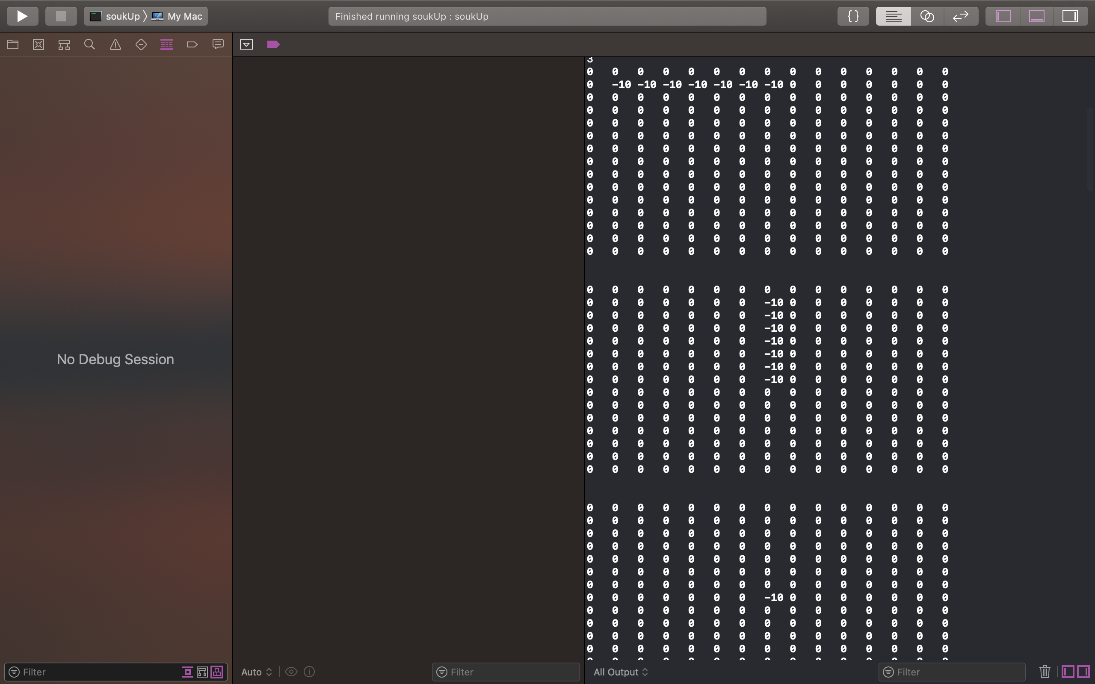

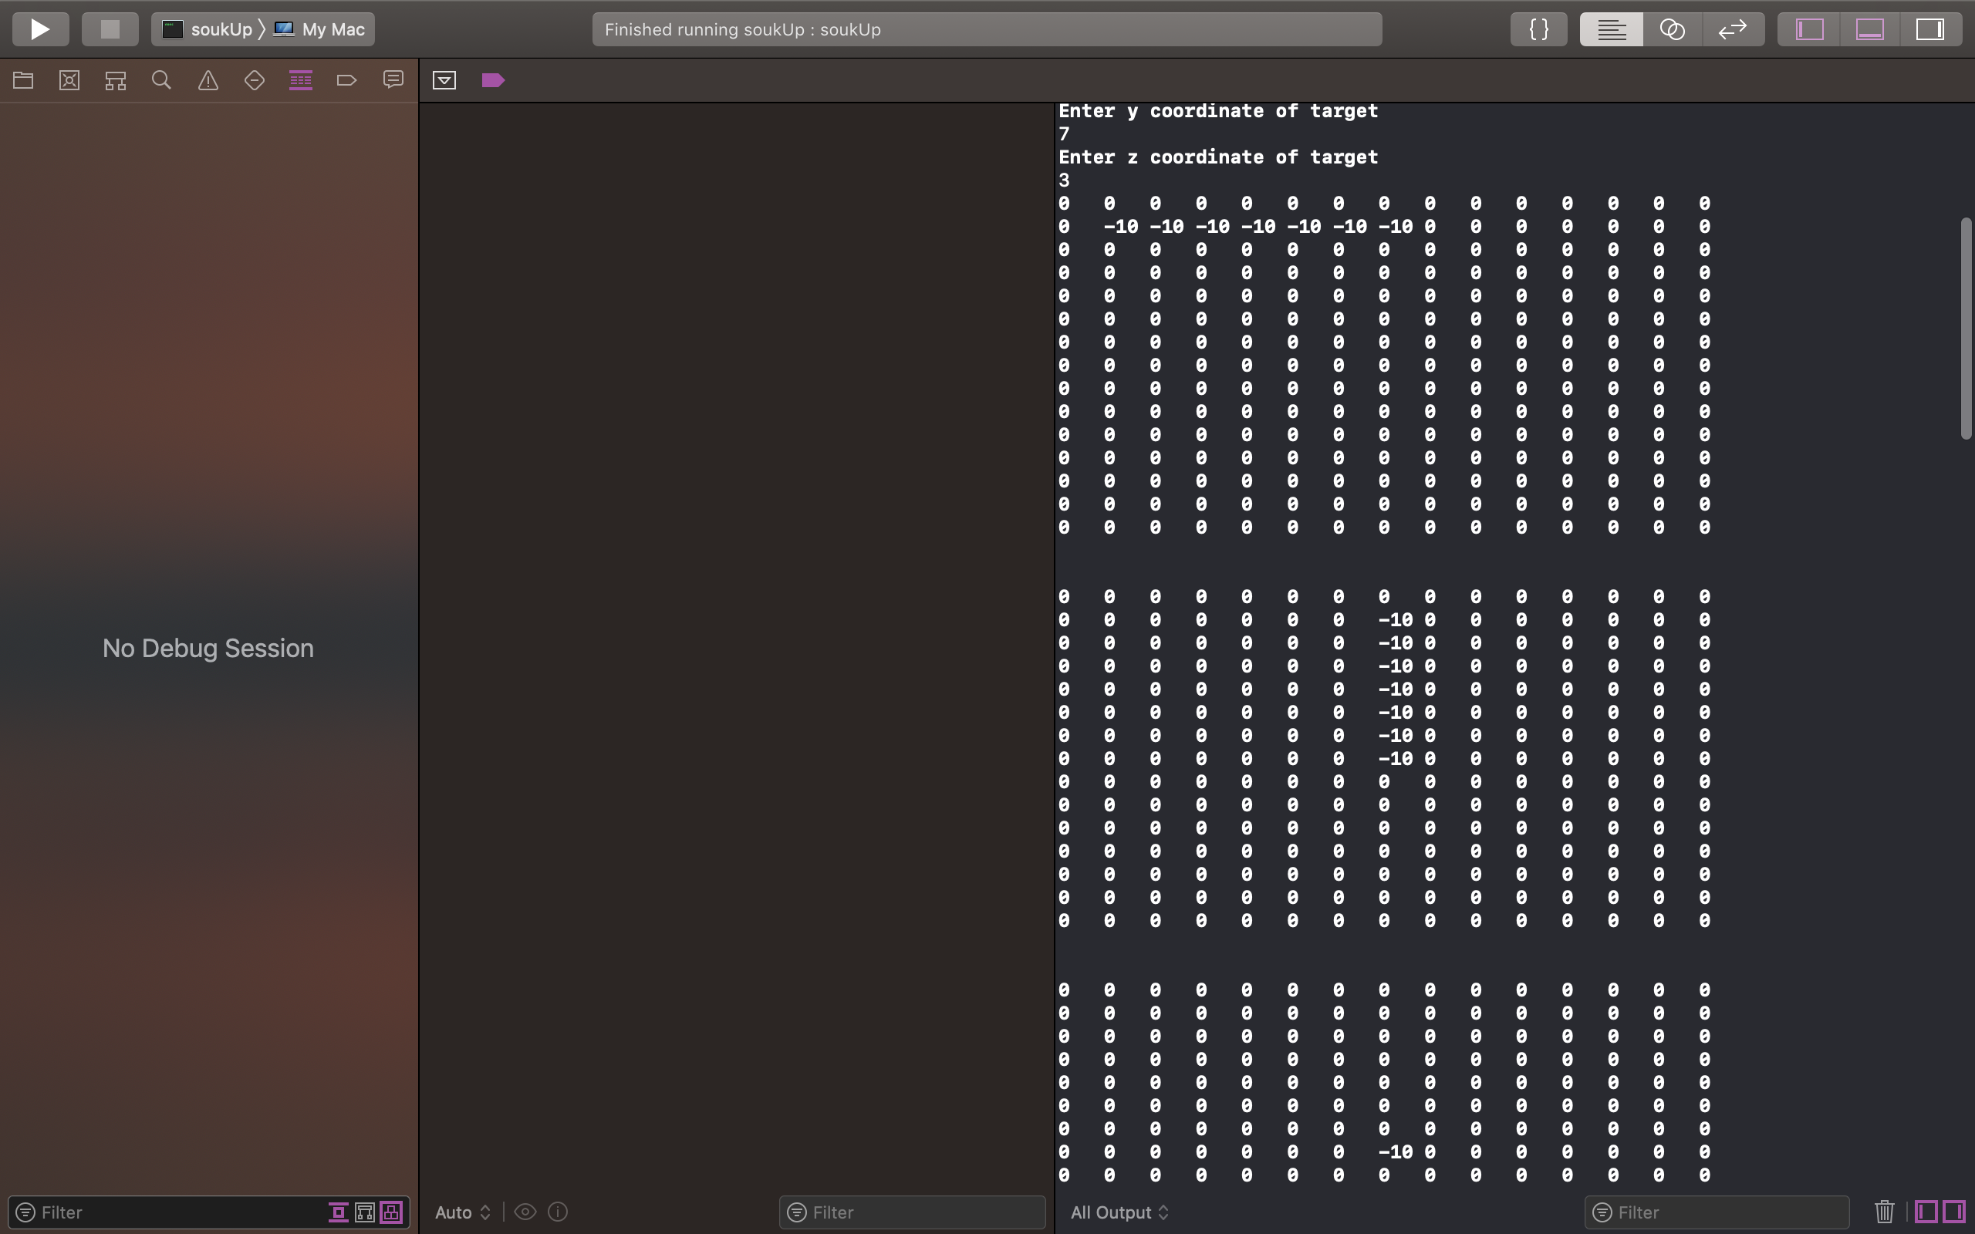

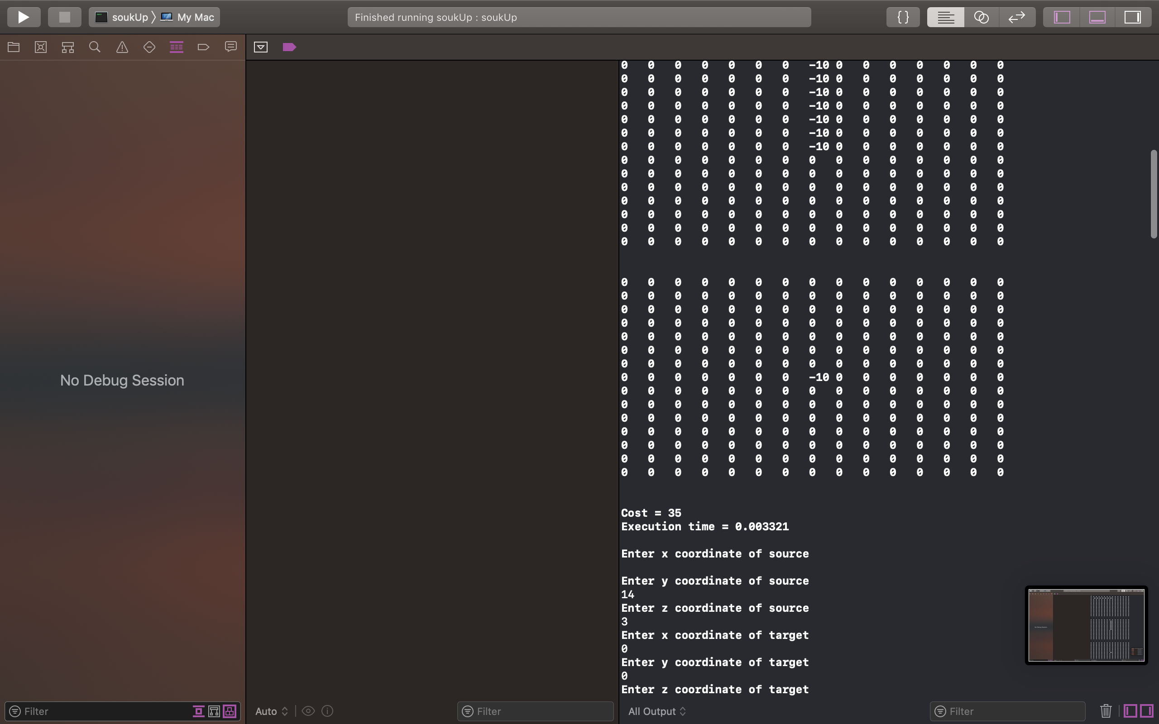

**Cost = 35**

**Execution time = 0.002981**

**Enter x coordinate of source**

14

**Enter y coordinate of source**

14

**Enter z coordinate of source**

3

**Enter x coordinate of target**

0

**Enter y coordinate of target**

0

**Enter z coordinate of target**

1

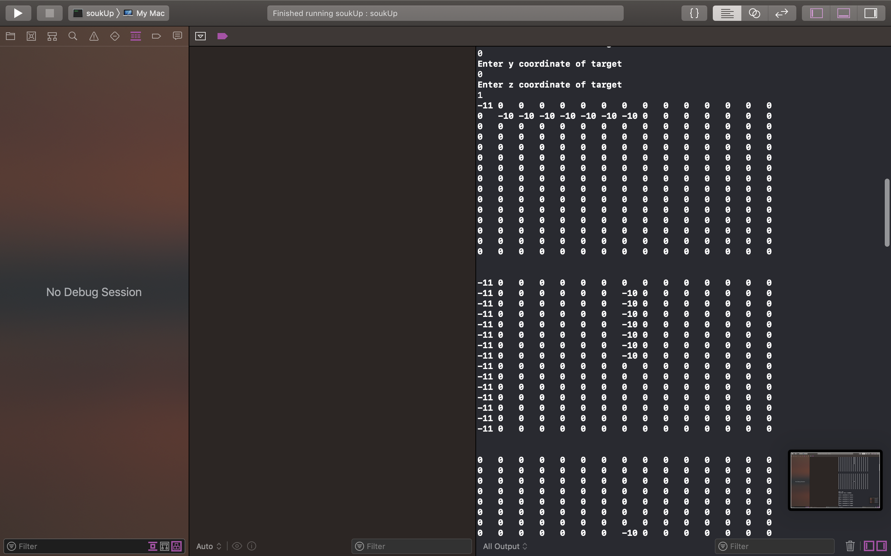



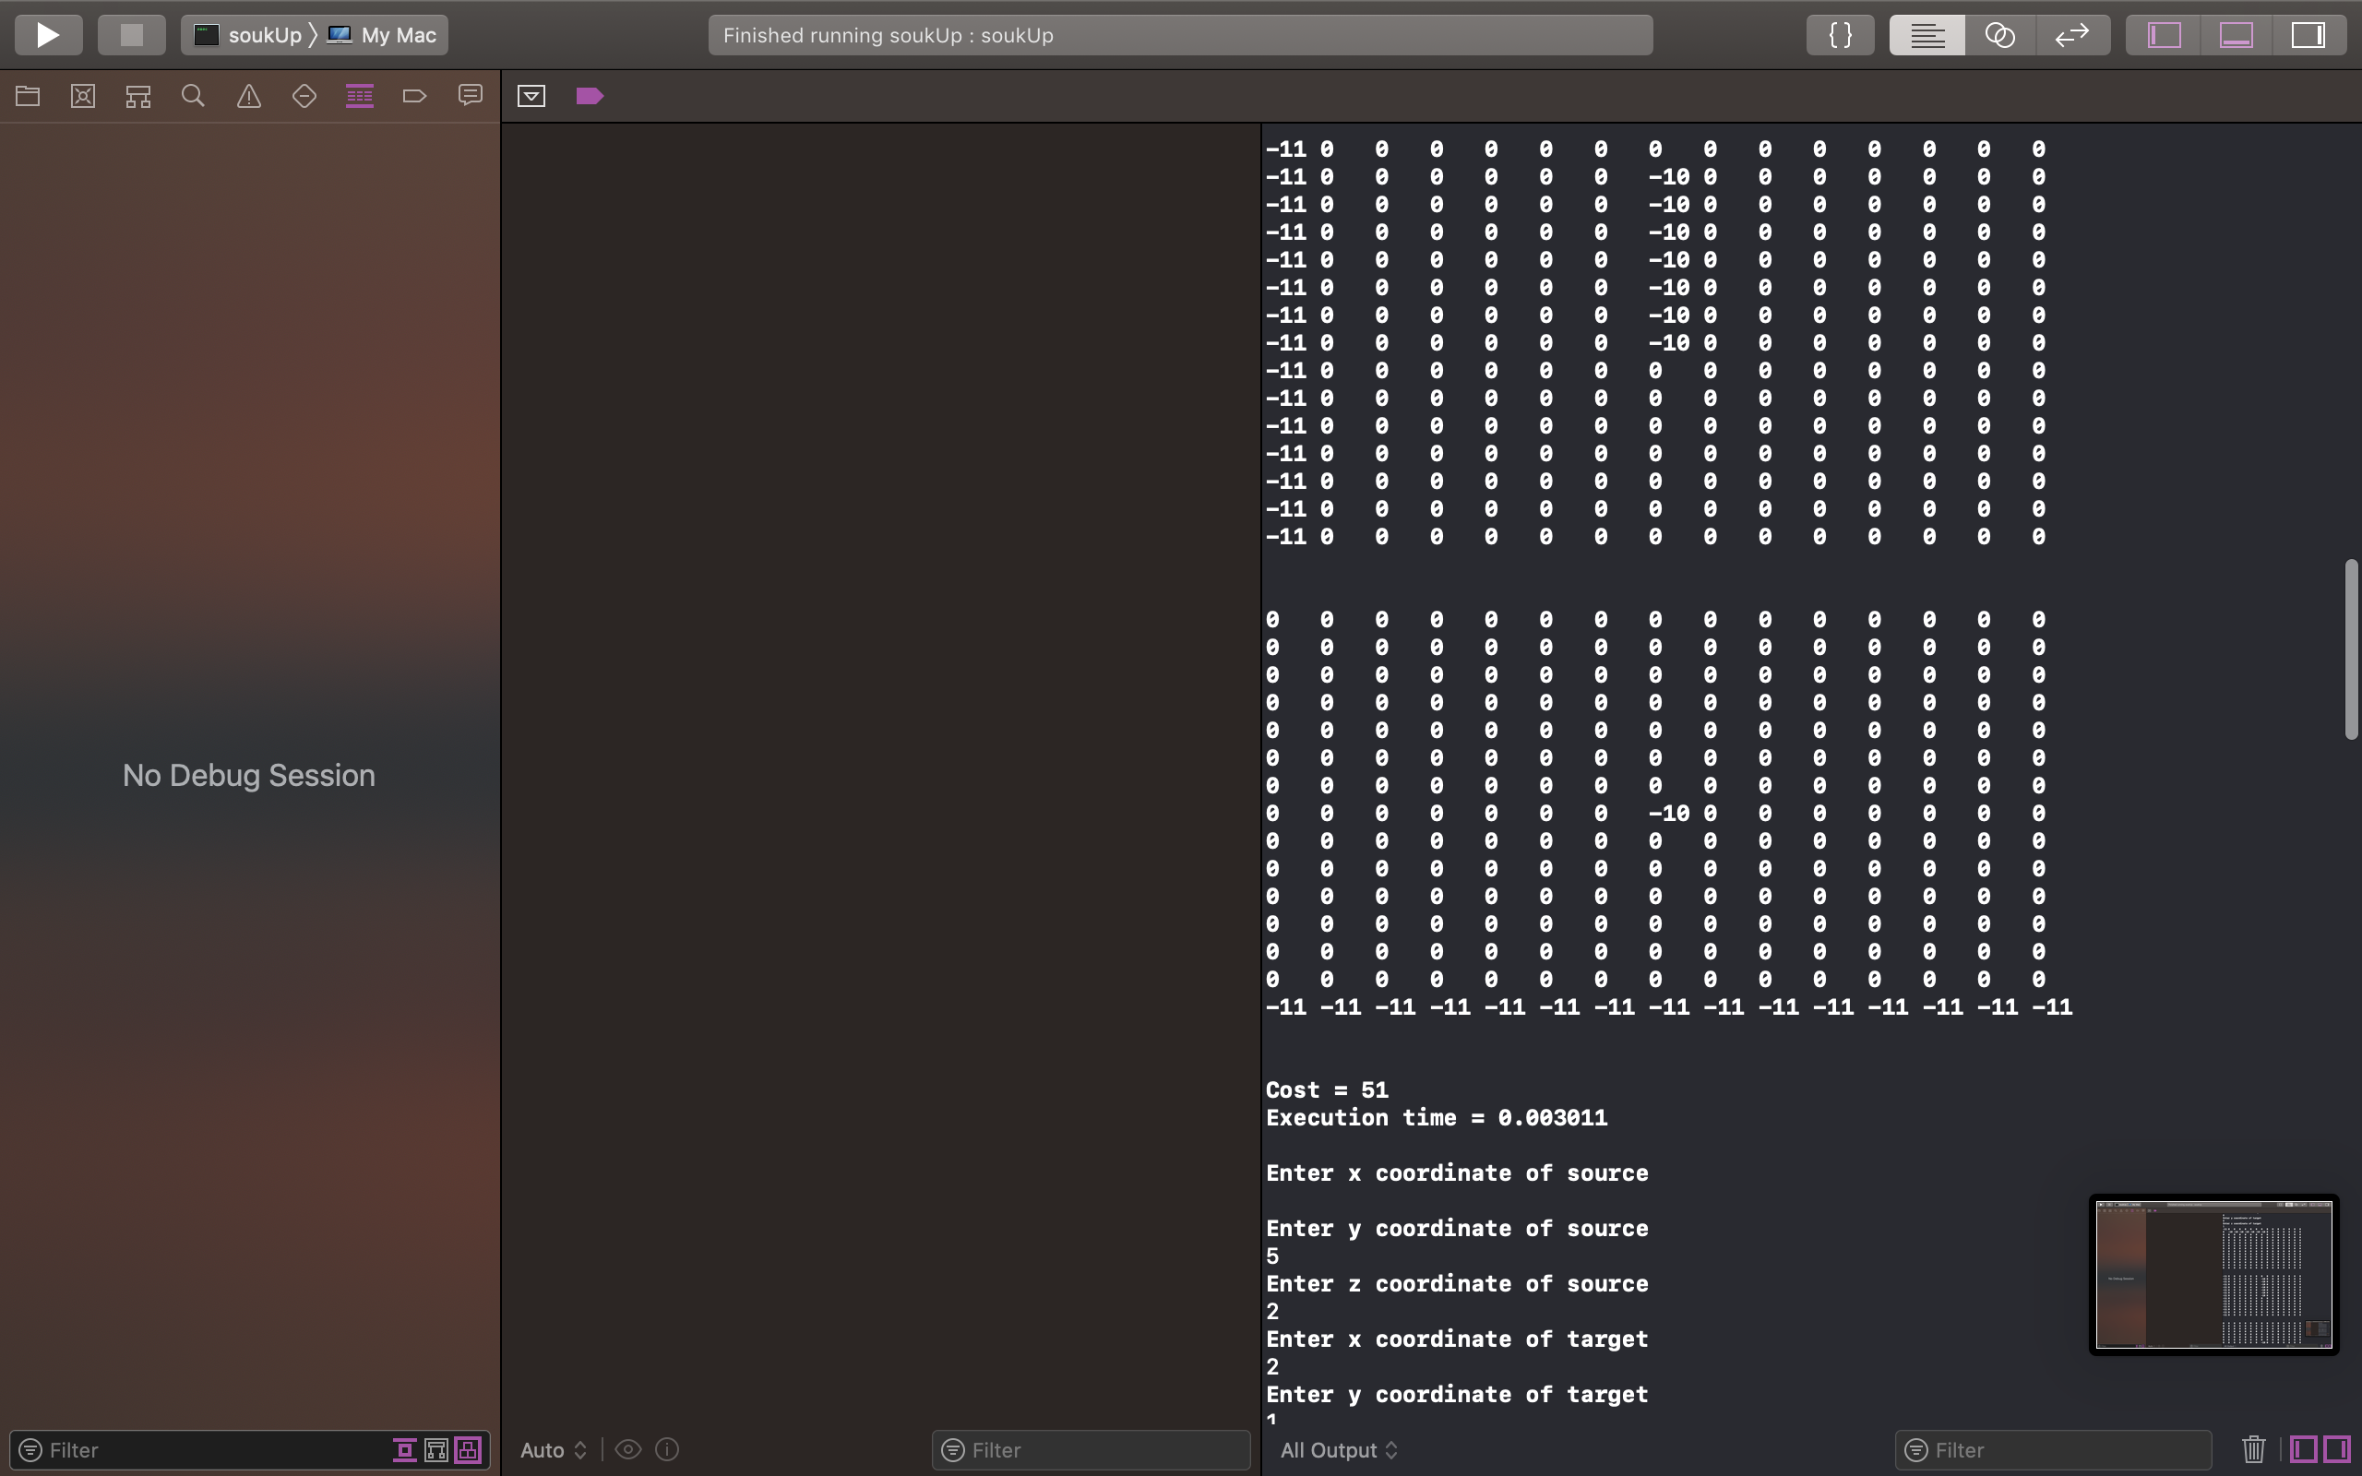

**Cost = 51**

**Execution time = 0.002903**

**Enter x coordinate of source**

5

**Enter y coordinate of source**

5

**Enter z coordinate of source**

2

**Enter x coordinate of target**

2

**Enter y coordinate of target**

1

**Enter z coordinate of target**

2

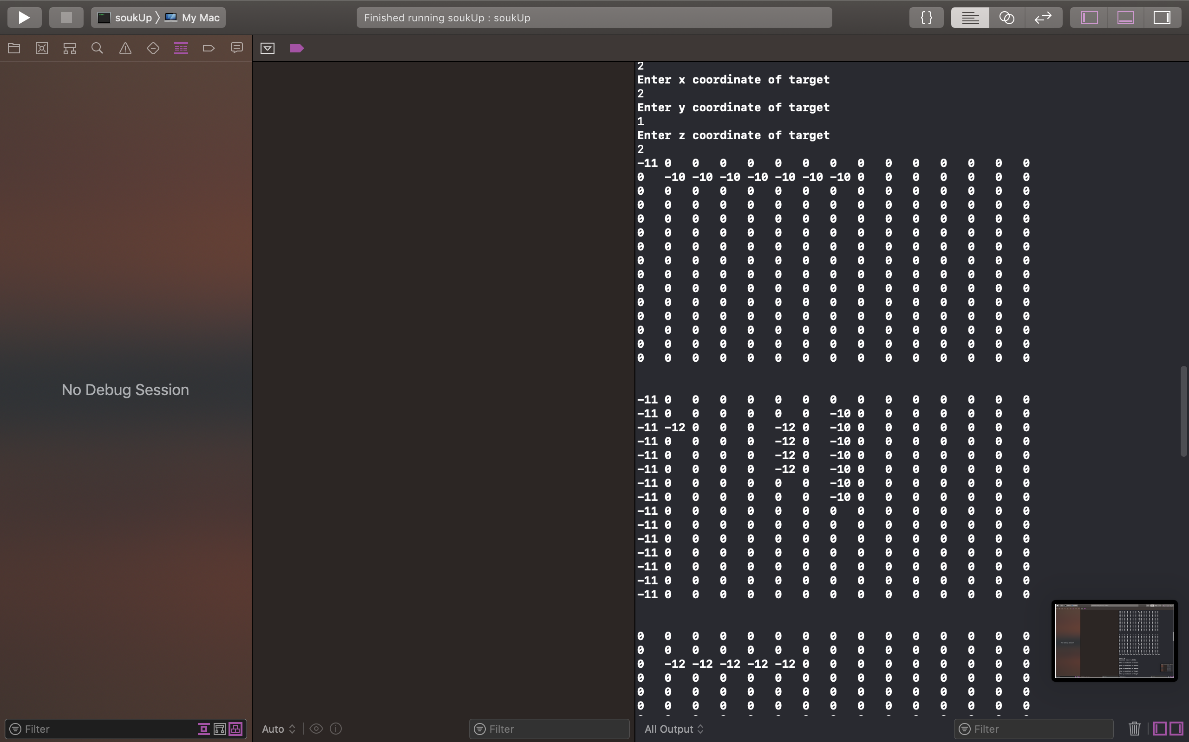

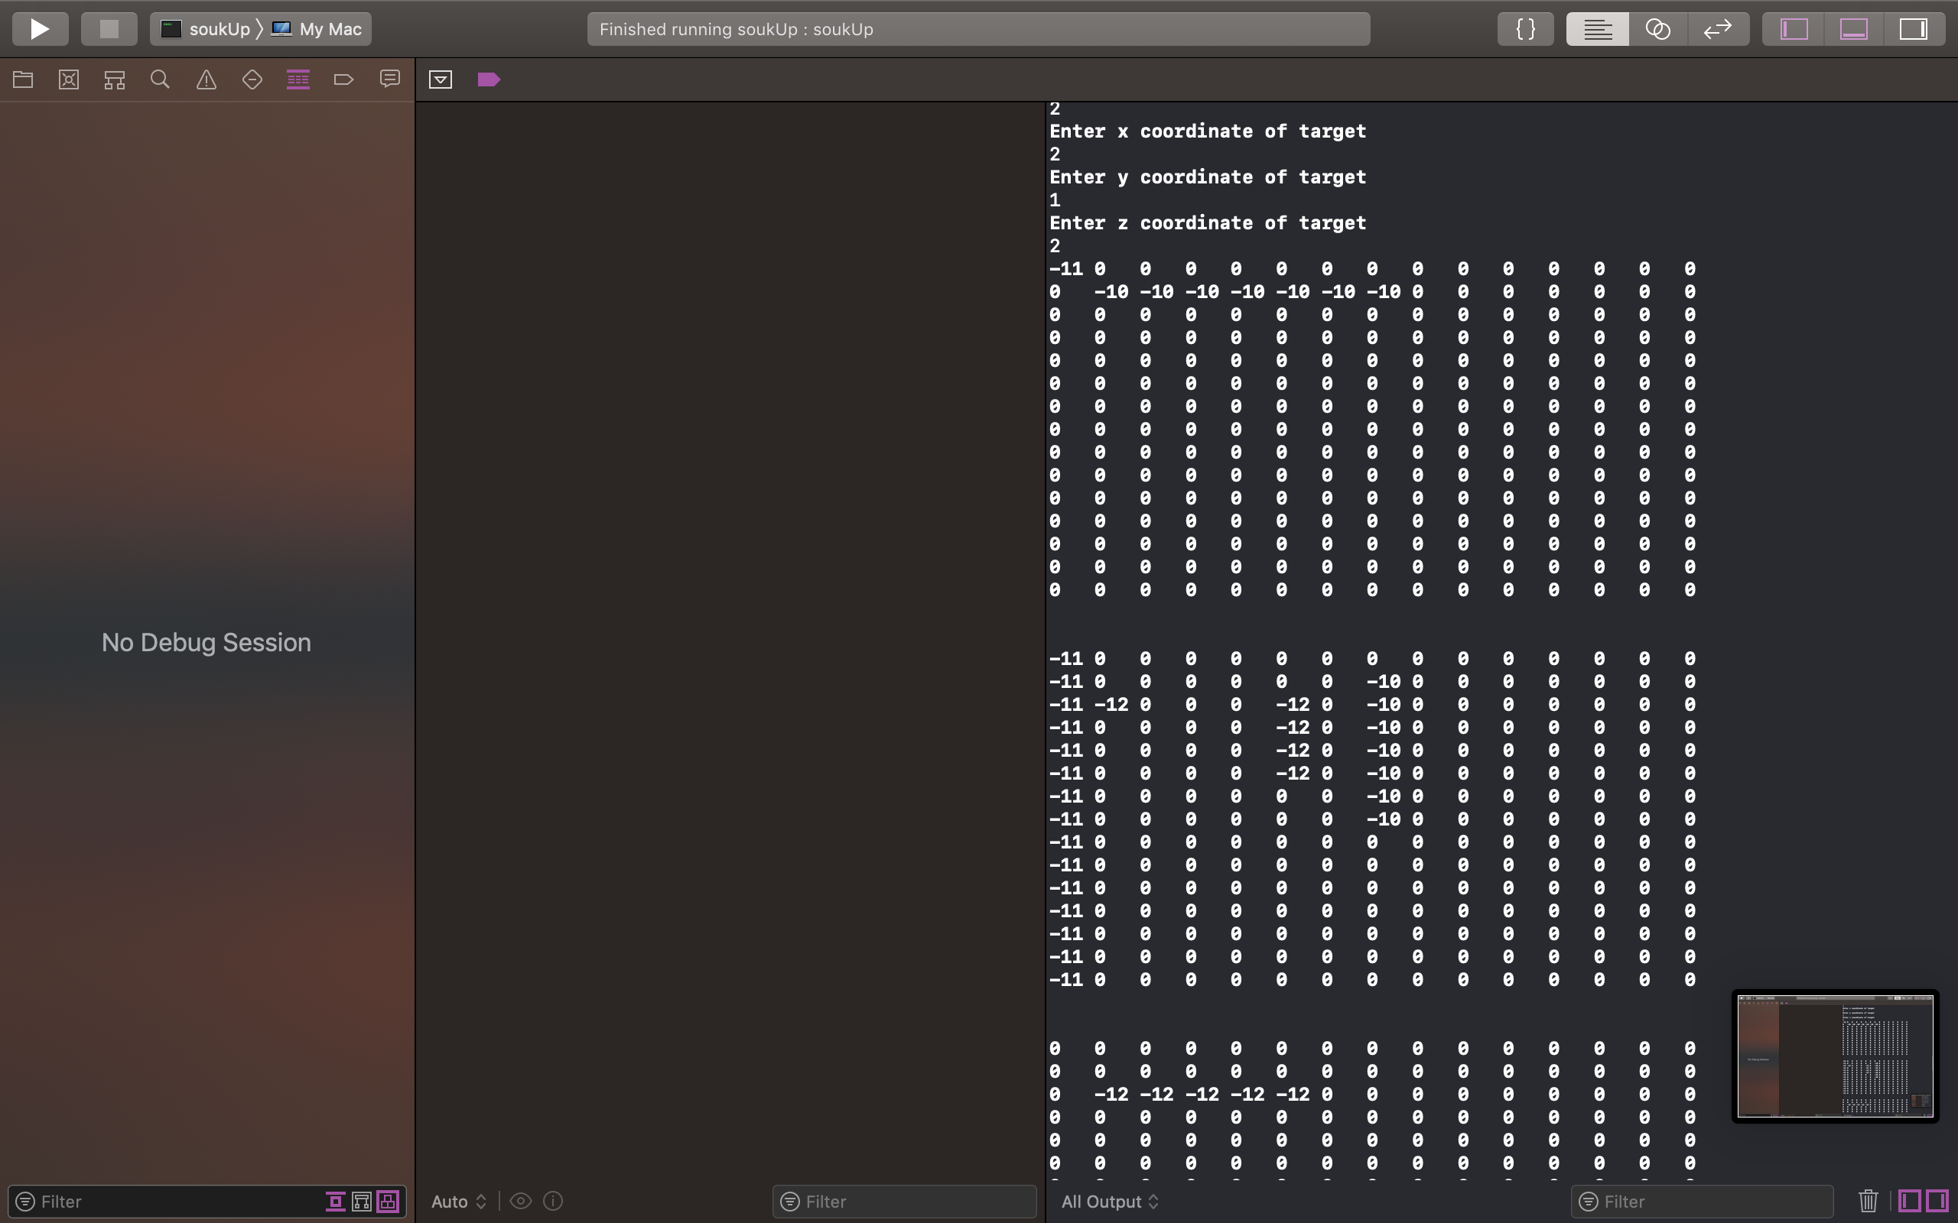

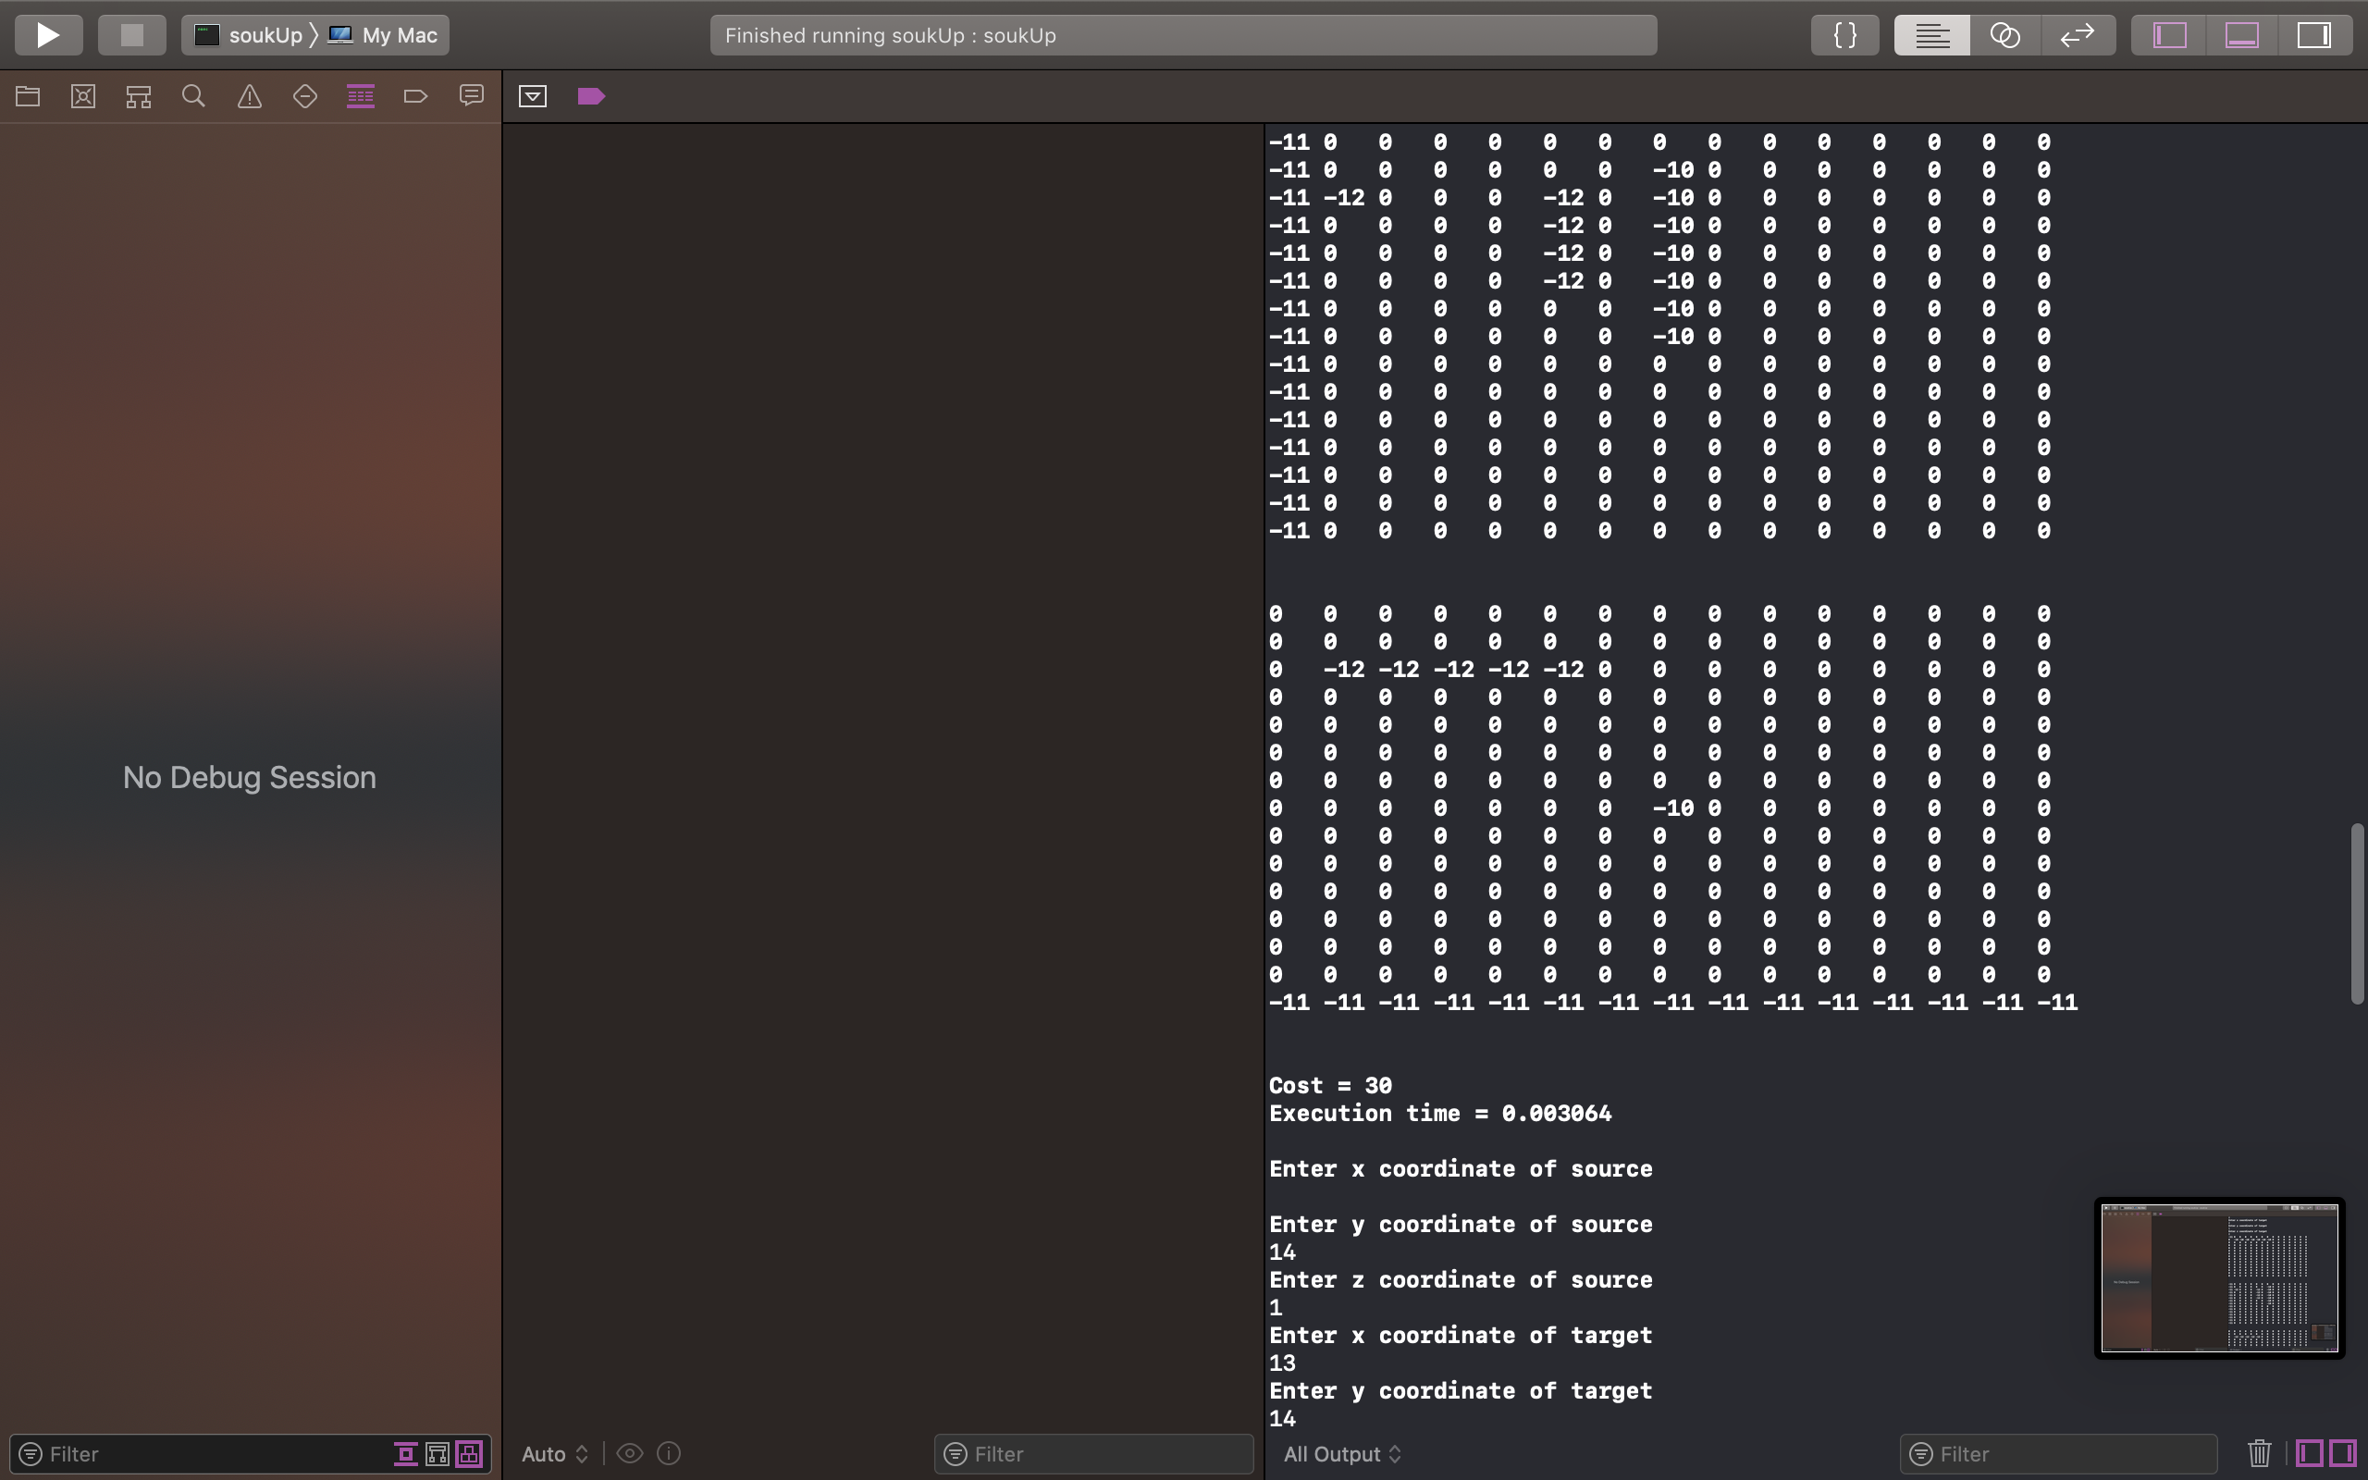

**Cost = 30**

**Execution time = 0.002751**

Testcase 6: (To showcase difference between floodless and classical)

**Please enter cost of via**

10

**Please enter the x-dimension of the plane**

15

**Please enter the y-dimension of the plane**

15

**If no path available, do you want to swap source and target and try again?**

**If yes enter 1, if no enter 0**

0

**Do you want to do DFS in more than one layer and thus flood less?**

**If yes enter 1, if no enter 0**

0

**Enter x coordinate of source**

1

**Enter y coordinate of source**

1

**Enter z coordinate of source**

1

**Enter x coordinate of target**

7

**Enter y coordinate of target**

7

**Enter z coordinate of target**

3

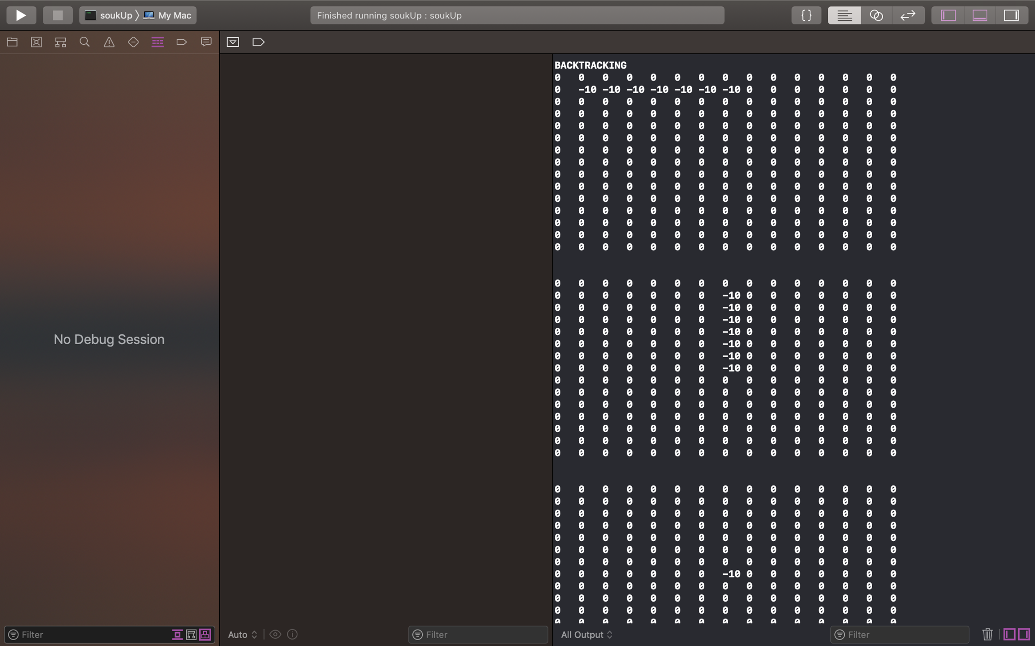

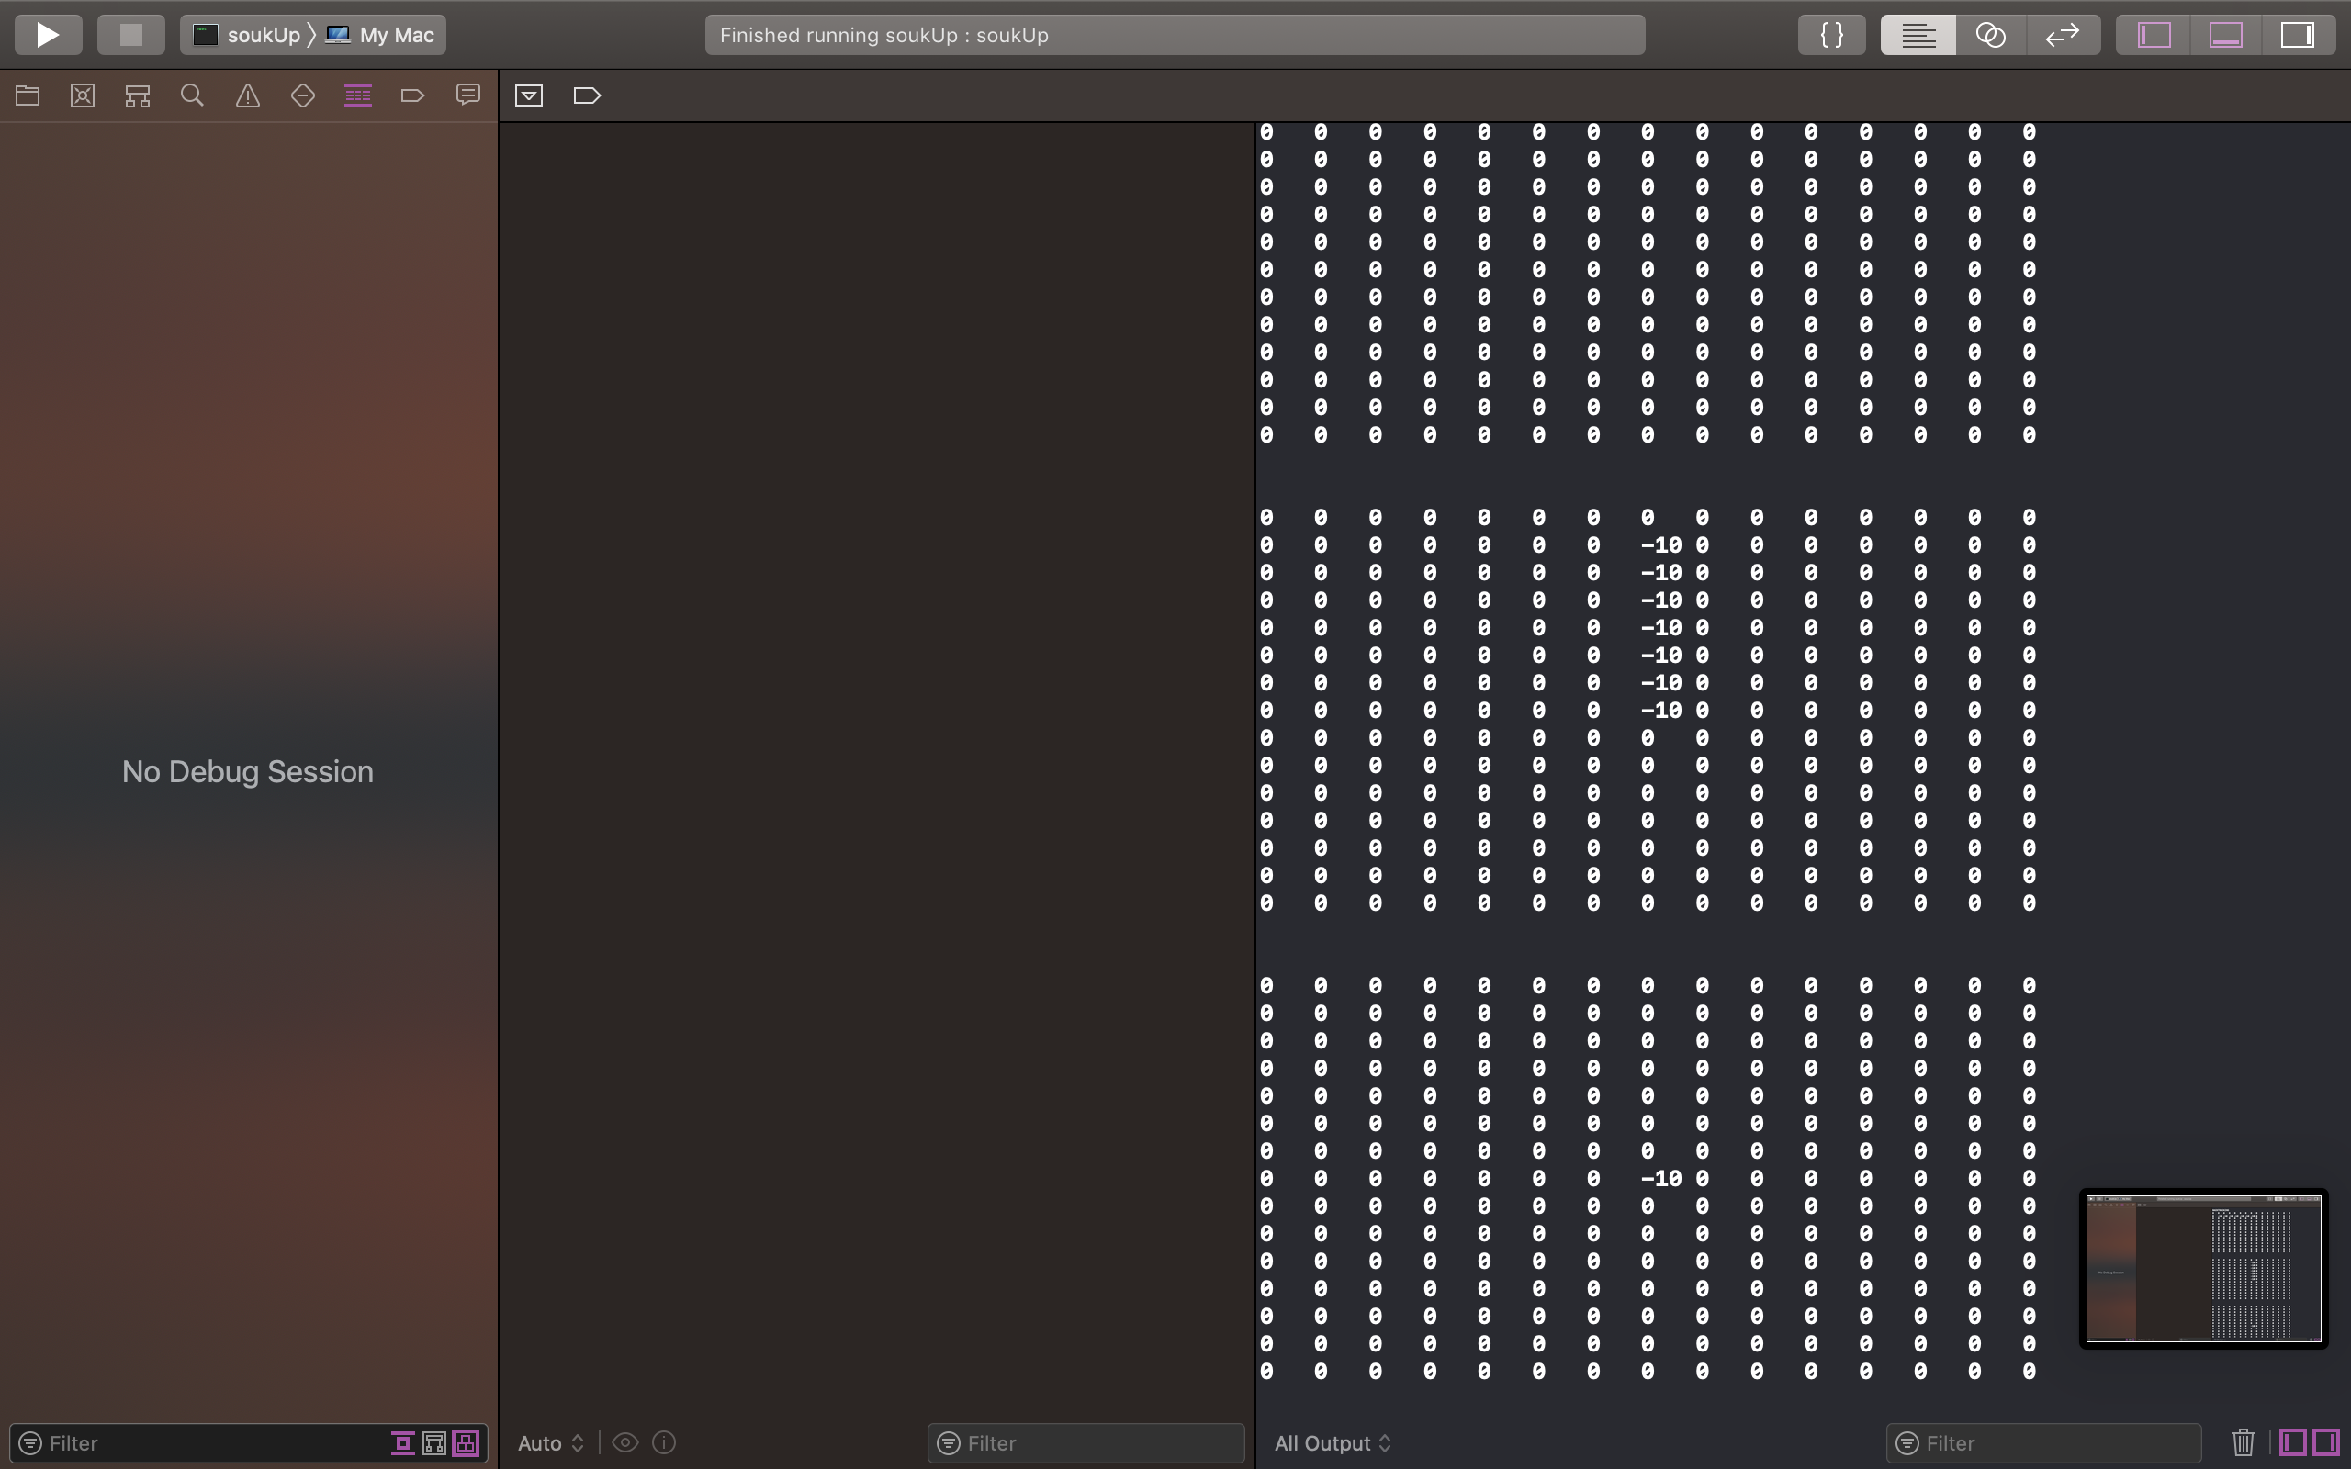

**Cost = 35**

**Execution time = 0.005312**

**Enter x coordinate of source**

14

**Enter y coordinate of source**

14

**Enter z coordinate of source**

3

**Enter x coordinate of target**

0

**Enter y coordinate of target**

0

**Enter z coordinate of target**

1

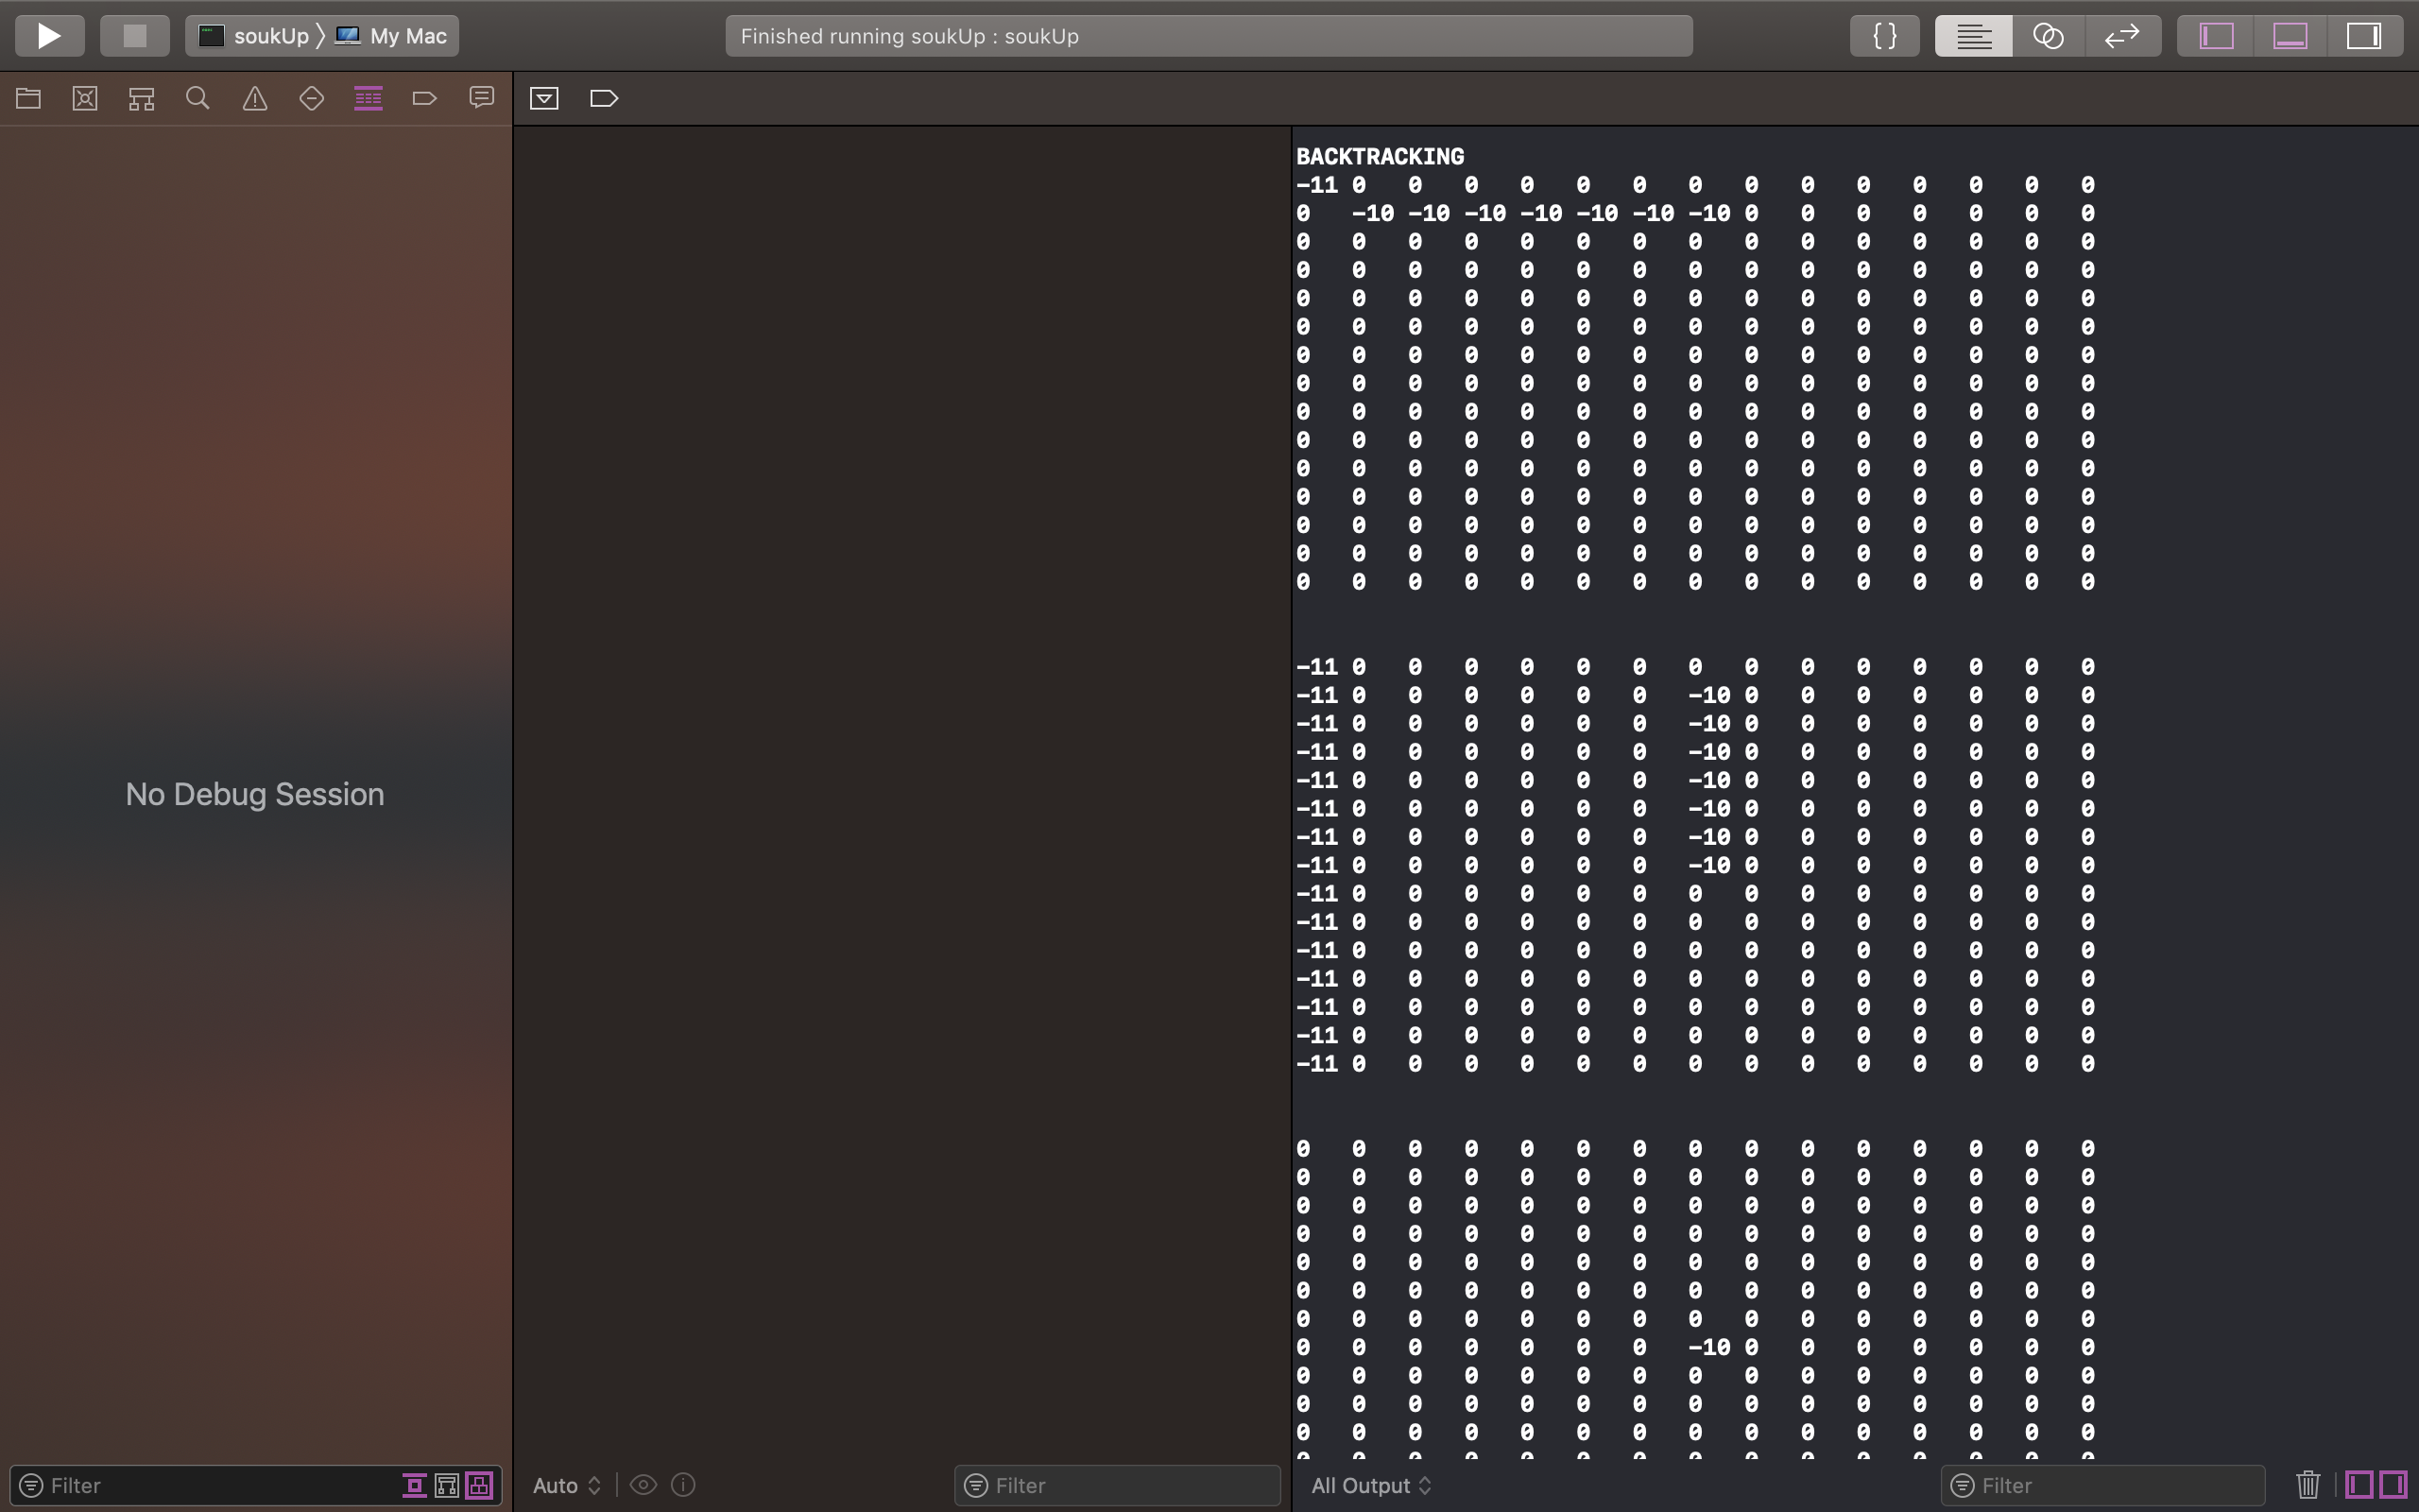

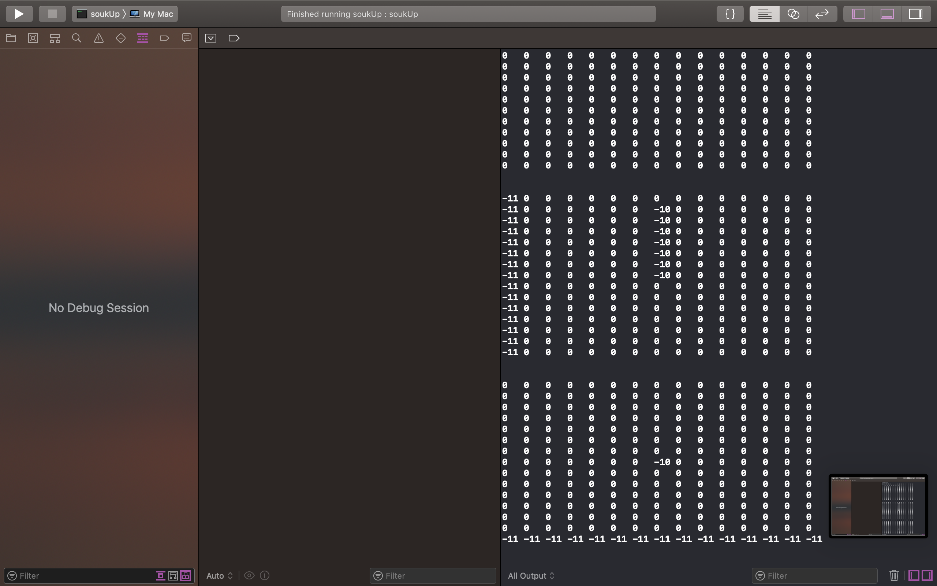

**Cost = 51**

**Execution time = 0.005454**

**Enter x coordinate of source**

5

**Enter y coordinate of source**

5

**Enter z coordinate of source**

2

**Enter x coordinate of target**

2

**Enter y coordinate of target**

1

**Enter z coordinate of target**

2

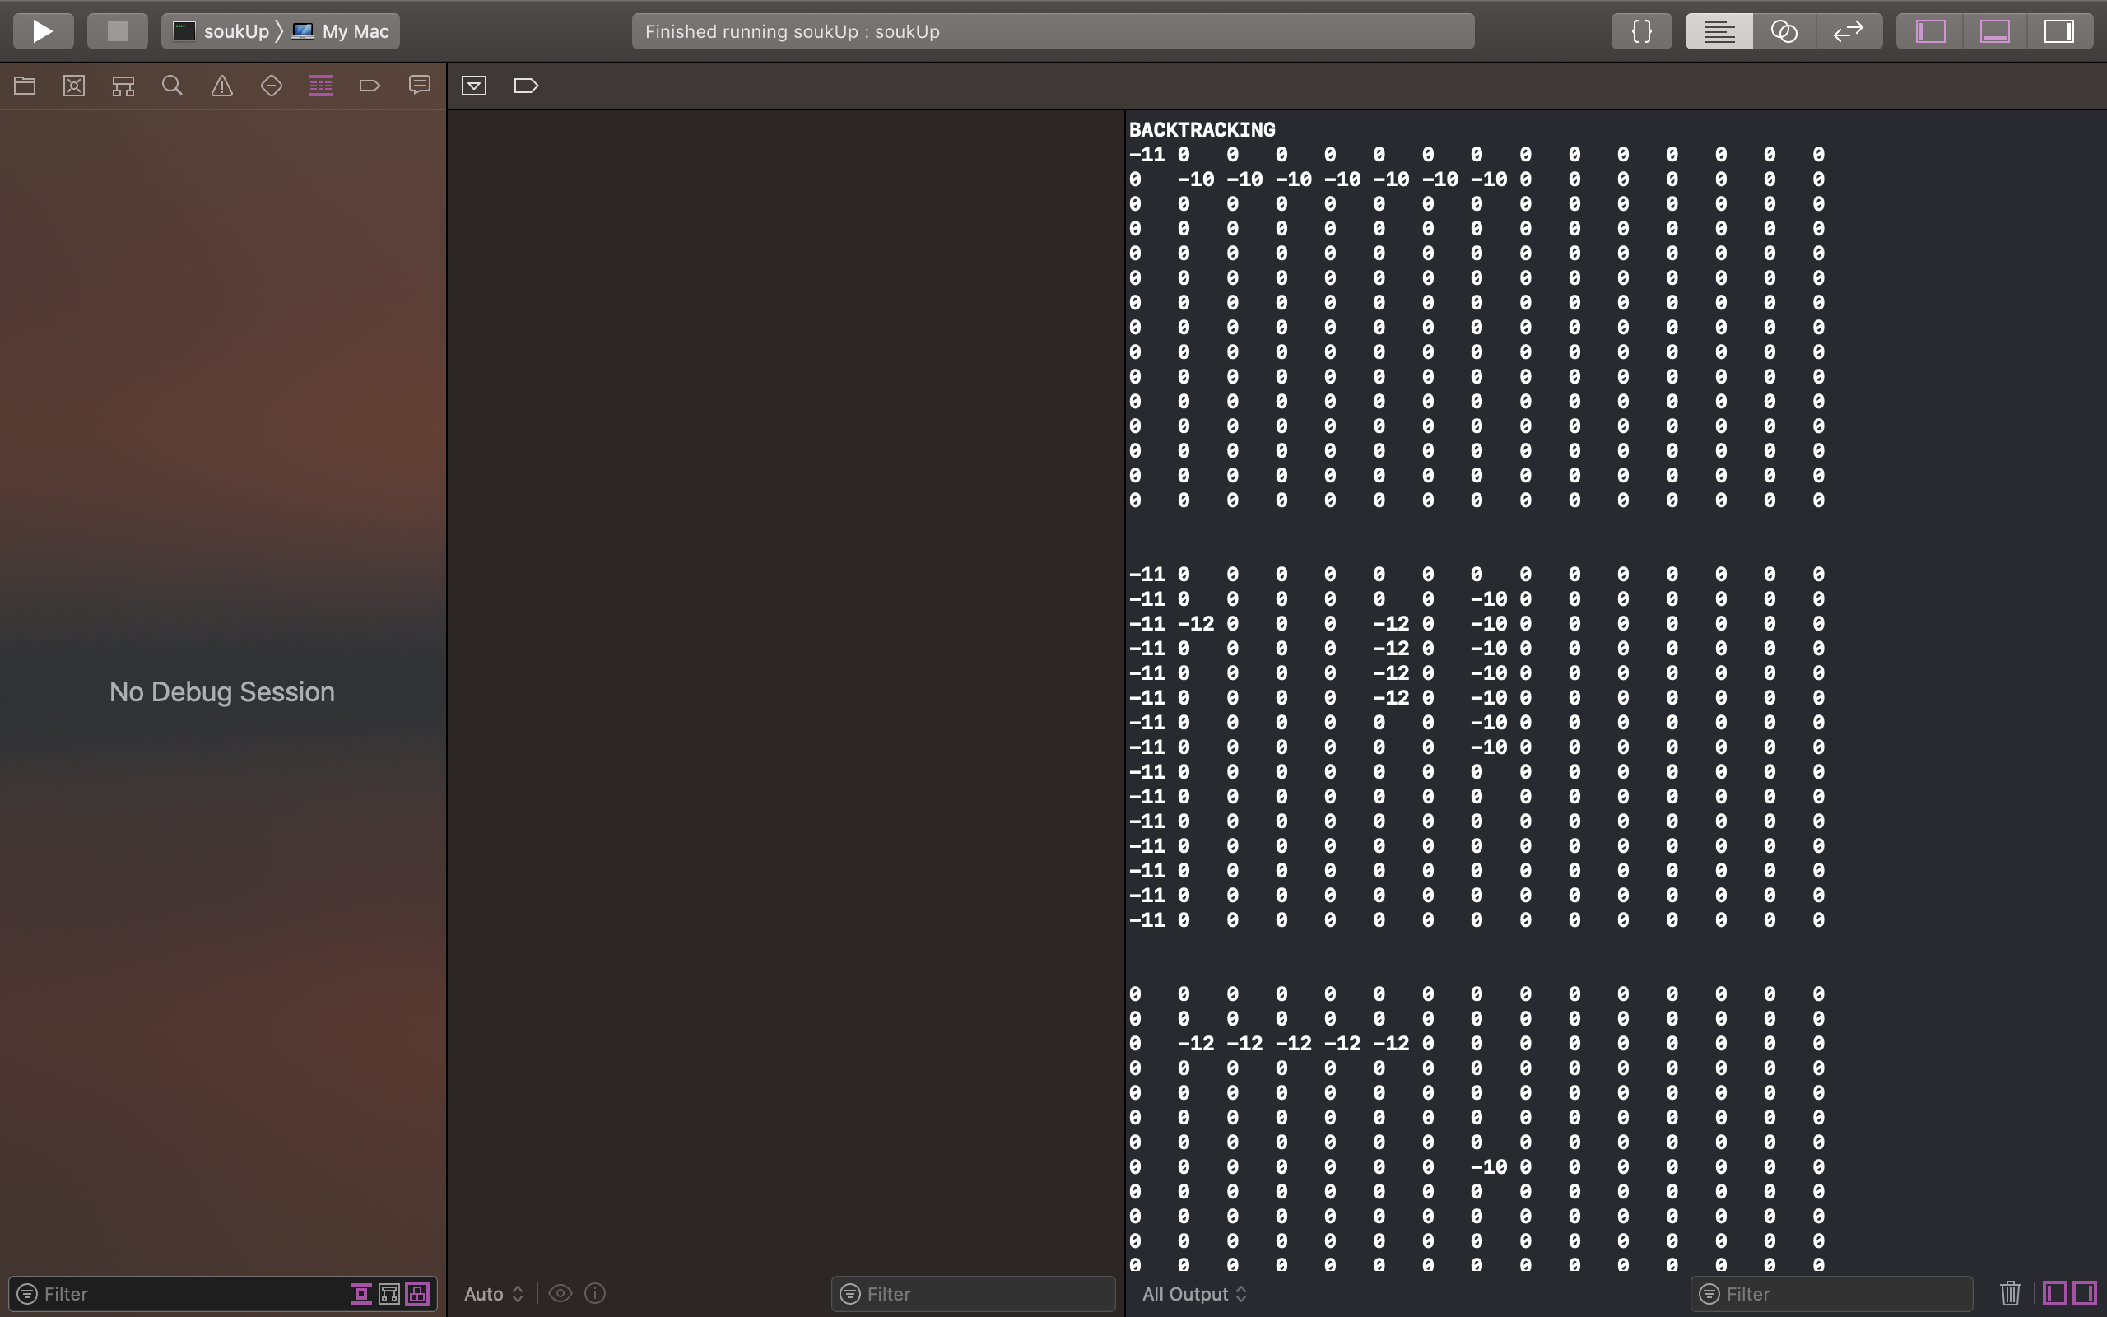

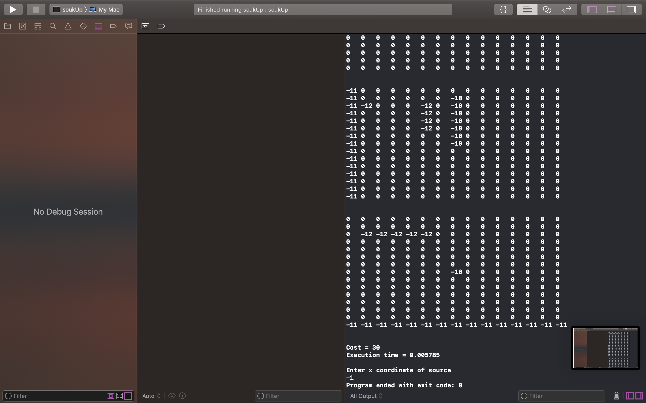

**Cost = 30**

**Execution time = 0.005785**

**Enter x coordinate of source**

-1

**Program ended with exit code: 0**

# Testcase 7:

**Please enter cost of via**

10

**Please enter the x-dimension of the plane**

5

**Please enter the y-dimension of the plane**

5

**If no path available, do you want to swap source and target and try again?**

**If yes enter 1, if no enter 0**

1

**Do you want to do DFS in more than one layer and thus flood less?**

**If yes enter 1, if no enter 0**

0

**Enter x coordinate of source**

1

**Enter y coordinate of source**

1

**Enter z coordinate of source**

1

**Enter x coordinate of target**

2

**Enter y coordinate of target**

3

**Enter z coordinate of target**

3

**BACKTRACKING**

**0 0 0 0 0**

**0 -10 -10 -10 0**

**0 0 0 0 0**

**0 0 0 0 0**

**0 0 0 0 0**

**0 0 0 0 0**

**0 0 0 -10 0**

**0 0 0 -10 0**

**0 0 0 0 0**

**0 0 0 0 0**

**0 0 0 0 0**

**0 0 0 0 0**

**0 0 0 -10 0**

**0 0 0 0 0**

**0 0 0 0 0**

**Cost = 26**

**Execution time = 0.001502**

**Enter x coordinate of source**

0

**Enter y coordinate of source**

0

**Enter z coordinate of source**

1

**Enter x coordinate of target**

3

**Enter y coordinate of target**

3

**Enter z coordinate of target**

2

**BACKTRACKING**

**-11 -11 -11 -11 -11**

**0 -10 -10 -10 0**

**0 0 0 0 0**

**0 0 0 0 0**

**0 0 0 0 0**

**0 0 0 0 -11**

**0 0 0 -10 -11**

**0 0 0 -10 -11**

**0 0 0 -11 -11**

**0 0 0 0 0**

**0 0 0 0 0**

**0 0 0 0 0**

**0 0 0 -10 0**

**0 0 0 -11 -11**

**0 0 0 0 0**

**Cost = 42**

**Execution time = 0.00096**

**Enter x coordinate of source**

0

**Enter y coordinate of source**

0

**Enter z coordinate of source**

1

**Enter x coordinate of target**

1

**Enter y coordinate of target**

0

**Enter z coordinate of target**

1

**BACKTRACKING**

**-12 -11 -11 -11 -11**

**-12 -10 -10 -10 0**

**0 0 0 0 0**

**0 0 0 0 0**

**0 0 0 0 0**

**-12 0 0 0 -11**

**-12 0 0 -10 -11**

**0 0 0 -10 -11**

**0 0 0 -11 -11**

**0 0 0 0 0**

**0 0 0 0 0**

**0 0 0 0 0**

**0 0 0 -10 0**

**0 0 0 -11 -11**

**0 0 0 0 0**

**Cost = 24**

**Execution time = 0.000757**

**Enter x coordinate of source**

0

**Enter y coordinate of source**

1

**Enter z coordinate of source**

1

**Enter x coordinate of target**

2

**Enter y coordinate of target**

5

**Enter y coordinate of target**

3

**Enter z coordinate of target**

3

**BACKTRACKING**

**-12 -13 -11 -11 -11**

**-12 -10 -10 -10 0**

**0 0 0 0 0**

**0 0 0 0 0**

**0 0 0 0 0**

**-12 -13 0 0 -11**

**-12 -13 0 -10 -11**

**0 -13 0 -10 -11**

**0 0 0 -11 -11**

**0 0 0 0 0**

**0 0 0 0 0**

**0 0 0 0 0**

**0 -13 -13 -13 0**

**0 0 0 -11 -11**

**0 0 0 0 0**

**Cost = 27**

**Execution time = 0.000888**

**Enter x coordinate of source**

1

**Enter y coordinate of source**

0

**Enter z coordinate of source**

1

**Enter x coordinate of target**

0

**Enter y coordinate of target**

3

**Enter z coordinate of target**

2

**No Path available**

**-12 -13 -11 -11 -11**

**-12 -10 -10 -10 0**

**0 0 0 0 0**

**0 0 0 0 0**

**0 0 0 0 0**

**-12 -13 0 0 -11**

**-12 -13 0 -10 -11**

**0 -13 0 -10 -11**

**0 0 0 -11 -11**

**0 0 0 0 0**

**0 0 0 0 0**

**0 0 0 0 0**

**0 -13 -13 -13 0**

**0 0 0 -11 -11**

**0 0 0 0 0**

**Execution time = 0.001182**

**Enter x coordinate of source**

4

**Enter y coordinate of source**

4

**Enter z coordinate of source**

3

**Enter x coordinate of target**

1

**Enter y coordinate of target**

1

**Enter z coordinate of target**

1

**No Path available**

**-12 -13 -11 -11 -11**

**-12 -10 -10 -10 0**

**0 0 0 0 0**

**0 0 0 0 0**

**0 0 0 0 0**

**-12 -13 0 0 -11**

**-12 -13 0 -10 -11**

**0 -13 0 -10 -11**

**0 0 0 -11 -11**

**0 0 0 0 0**

**0 0 0 0 0**

**0 0 0 0 0**

**0 -13 -13 -13 0**

**0 0 0 -11 -11**

**0 0 0 0 0**

**Execution time = 0.001448**

**Enter x coordinate of source**

-1

**Program ended with exit code: 0**

# Testcase 8:

**Please enter cost of via**

10

**Please enter the x-dimension of the plane**

5

**Please enter the y-dimension of the plane**

5

**If no path available, do you want to swap source and target and try again?**

**If yes enter 1, if no enter 0**

1

**Do you want to do DFS in more than one layer and thus flood less?**

**If yes enter 1, if no enter 0**

0

**Enter x coordinate of source**

1

**Enter y coordinate of source**

1

**Enter z coordinate of source**

1

**Enter x coordinate of target**

2

**Enter y coordinate of target**

3

**Enter z coordinate of target**

3

**BACKTRACKING**

**0 0 0 0 0**

**0 -10 -10 -10 0**

**0 0 0 0 0**

**0 0 0 0 0**

**0 0 0 0 0**

**0 0 0 0 0**

**0 0 0 -10 0**

**0 0 0 -10 0**

**0 0 0 0 0**

**0 0 0 0 0**

**0 0 0 0 0**

**0 0 0 0 0**

**0 0 0 -10 0**

**0 0 0 0 0**

**0 0 0 0 0**

**Cost = 26**

**Execution time = 0.000495**

**Enter x coordinate of source**

0

**Enter y coordinate of source**

0

**Enter z coordinate of source**

1

**Enter x coordinate of target**

3

**Enter y coordinate of target**

3

**Enter z coordinate of target**

2

**BACKTRACKING**

**-11 -11 -11 -11 -11**

**0 -10 -10 -10 0**

**0 0 0 0 0**

**0 0 0 0 0**

**0 0 0 0 0**

**0 0 0 0 -11**

**0 0 0 -10 -11**

**0 0 0 -10 -11**

**0 0 0 -11 -11**

**0 0 0 0 0**

**0 0 0 0 0**

**0 0 0 0 0**

**0 0 0 -10 0**

**0 0 0 -11 -11**

**0 0 0 0 0**

**Cost = 42**

**Execution time = 0.000449**

**Enter x coordinate of source**

0

**Enter y coordinate of source**

0

**Enter z coordinate of source**

1

**Enter x coordinate of target**

1

**Enter y coordinate of target**

0

**Enter z coordinate of target**

1

**BACKTRACKING**

**-12 -11 -11 -11 -11**

**-12 -10 -10 -10 0**

**0 0 0 0 0**

**0 0 0 0 0**

**0 0 0 0 0**

**-12 0 0 0 -11**

**-12 0 0 -10 -11**

**0 0 0 -10 -11**

**0 0 0 -11 -11**

**0 0 0 0 0**

**0 0 0 0 0**

**0 0 0 0 0**

**0 0 0 -10 0**

**0 0 0 -11 -11**

**0 0 0 0 0**

**Cost = 24**

**Execution time = 0.000408**

**Enter x coordinate of source**

0

**Enter y coordinate of source**

1

**Enter z coordinate of source**

1

**Enter x coordinate of target**

2

**Enter y coordinate of target**

5

**Enter y coordinate of target**

3

**Enter z coordinate of target**

3

**BACKTRACKING**

**-12 -13 -11 -11 -11**

**-12 -10 -10 -10 0**

**0 0 0 0 0**

**0 0 0 0 0**

**0 0 0 0 0**

**-12 -13 0 0 -11**

**-12 -13 0 -10 -11**

**0 -13 0 -10 -11**

**0 0 0 -11 -11**

**0 0 0 0 0**

**0 0 0 0 0**

**0 0 0 0 0**

**0 -13 -13 -13 0**

**0 0 0 -11 -11**

**0 0 0 0 0**

**Cost = 27**

**Execution time = 0.000519**

**Enter x coordinate of source**

1

**Enter y coordinate of source**

0

**Enter z coordinate of source**

1

**Enter x coordinate of target**

0

**Enter y coordinate of target**

3

**Enter z coordinate of target**

2

**No Path available**

**-12 -13 -11 -11 -11**

**-12 -10 -10 -10 0**

**0 0 0 0 0**

**0 0 0 0 0**

**0 0 0 0 0**

**-12 -13 0 0 -11**

**-12 -13 0 -10 -11**

**0 -13 0 -10 -11**

**0 0 0 -11 -11**

**0 0 0 0 0**

**0 0 0 0 0**

**0 0 0 0 0**

**0 -13 -13 -13 0**

**0 0 0 -11 -11**

**0 0 0 0 0**

**Execution time = 0.000447**

**Enter x coordinate of source**

4

**Enter y coordinate of source**

4

**Enter z coordinate of source**

3

**Enter x coordinate of target**

1

**Enter y coordinate of target**

1

**Enter z coordinate of target**

1

**No Path available**

**-12 -13 -11 -11 -11**

**-12 -10 -10 -10 0**

**0 0 0 0 0**

**0 0 0 0 0**

**0 0 0 0 0**

**-12 -13 0 0 -11**

**-12 -13 0 -10 -11**

**0 -13 0 -10 -11**

**0 0 0 -11 -11**

**0 0 0 0 0**

**0 0 0 0 0**

**0 0 0 0 0**

**0 -13 -13 -13 0**

**0 0 0 -11 -11**

**0 0 0 0 0**

**Execution time = 0.00046**

**Enter x coordinate of source**

-1

**Program ended with exit code: 0**

# Testcase 9:

**Please enter cost of via**

10

**Please enter the x-dimension of the plane**

7

**Please enter the y-dimension of the plane**

3

**If no path available, do you want to swap source and target and try again?**

**If yes enter 1, if no enter 0**

1

**Do you want to do DFS in more than one layer and thus flood less?**

**If yes enter 1, if no enter 0**

0

**Enter x coordinate of source**

1

**Enter y coordinate of source**

1

**Enter z coordinate of source**

1

**Enter x coordinate of target**

2

**Enter y coordinate of target**

1

**Enter z coordinate of target**

3

**BACKTRACKING**

**0 0 0**

**0 -10 0**

**0 0 0**

**0 0 0**

**0 0 0**

**0 0 0**

**0 0 0**

**0 0 0**

**0 -10 0**

**0 -10 0**

**0 0 0**

**0 0 0**

**0 0 0**

**0 0 0**

**0 0 0**

**0 0 0**

**0 -10 0**

**0 0 0**

**0 0 0**

**0 0 0**

**0 0 0**

**Cost = 24**

**Execution time = 0.001109**

**Enter x coordinate of source**

0

**Enter y coordinate of source**

0

**Enter z coordinate of source**

1

**Enter x coordinate of target**

6

**Enter y coordinate of target**

3

**Enter y coordinate of target**

2

**Enter z coordinate of target**

3

**BACKTRACKING**

**-11 -11 -11**

**0 -10 0**

**0 0 0**

**0 0 0**

**0 0 0**

**0 0 0**

**0 0 0**

**0 0 -11**

**0 -10 -11**

**0 -10 -11**

**0 0 -11**

**0 0 -11**

**0 0 -11**

**0 0 -11**

**0 0 0**

**0 0 0**

**0 -10 0**

**0 0 0**

**0 0 0**

**0 0 0**

**0 0 -11**

**Cost = 31**

**Execution time = 0.001236**

**Enter x coordinate of source**

1

**Enter y coordinate of source**

0

**Enter z coordinate of source**

1

**Enter x coordinate of target**

1

**Enter y coordinate of target**

0

**Enter z coordinate of target**

1

**-11 -11 -11**

**-12 -10 0**

**0 0 0**

**0 0 0**

**0 0 0**

**0 0 0**

**0 0 0**

**0 0 -11**

**0 -10 -11**

**0 -10 -11**

**0 0 -11**

**0 0 -11**

**0 0 -11**

**0 0 -11**

**0 0 0**

**0 0 0**

**0 -10 0**

**0 0 0**

**0 0 0**

**0 0 0**

**0 0 -11**

**Cost = 1**

**Execution time = 0.000376**

**Enter x coordinate of source**

5

**Enter y coordinate of source**

2

**Enter z coordinate of source**

3

**Enter x coordinate of target**

1

**Enter y coordinate of target**

0

**Enter z coordinate of target**

1

**BACKTRACKING**

**-11 -11 -11**

**-13 -10 0**

**0 0 0**

**0 0 0**

**0 0 0**

**0 0 0**

**0 0 0**

**0 0 -11**

**-13 -10 -11**

**-13 -10 -11**

**-13 0 -11**

**-13 0 -11**

**-13 0 -11**

**0 0 -11**

**0 0 0**

**0 0 0**

**0 -10 0**

**0 0 0**

**0 0 0**

**-13 -13 -13**

**0 0 -11**

**Cost = 29**

**Execution time = 0.001121**

**Enter x coordinate of source**

1

**Enter y coordinate of source**

2

**Enter z coordinate of source**

1

**Enter x coordinate of target**

4

**Enter y coordinate of target**

0

**Enter z coordinate of target**

3

**No Path available**

**-11 -11 -11**

**-13 -10 0**

**0 0 0**

**0 0 0**

**0 0 0**

**0 0 0**

**0 0 0**

**0 0 -11**

**-13 -10 -11**

**-13 -10 -11**

**-13 0 -11**

**-13 0 -11**

**-13 0 -11**

**0 0 -11**

**0 0 0**

**0 0 0**

**0 -10 0**

**0 0 0**

**0 0 0**

**-13 -13 -13**

**0 0 -11**

**Execution time = 0.001086**

**Enter x coordinate of source**

-1

**Program ended with exit code: 0**

# Testcase 10:

**Please enter cost of via**

10

**Please enter the x-dimension of the plane**

7

**Please enter the y-dimension of the plane**

3

**If no path available, do you want to swap source and target and try again?**

**If yes enter 1, if no enter 0**

0

**Do you want to do DFS in more than one layer and thus flood less?**

**If yes enter 1, if no enter 0**

0

**Enter x coordinate of source**

1

**Enter y coordinate of source**

1

**Enter z coordinate of source**

1

**Enter x coordinate of target**

2

**Enter y coordinate of target**

1

**Enter z coordinate of target**

3

**BACKTRACKING**

**0 0 0**

**0 -10 0**

**0 0 0**

**0 0 0**

**0 0 0**

**0 0 0**

**0 0 0**

**0 0 0**

**0 -10 0**

**0 -10 0**

**0 0 0**

**0 0 0**

**0 0 0**

**0 0 0**

**0 0 0**

**0 0 0**

**0 -10 0**

**0 0 0**

**0 0 0**

**0 0 0**

**0 0 0**

**Cost = 24**

**Execution time = 0.000682**

**Enter x coordinate of source**

0

**Enter y coordinate of source**

0

**Enter z coordinate of source**

1

**Enter x coordinate of target**

6

**Enter y coordinate of target**

2

**Enter z coordinate of target**

3

**BACKTRACKING**

**-11 -11 -11**

**0 -10 0**

**0 0 0**

**0 0 0**

**0 0 0**

**0 0 0**

**0 0 0**

**0 0 -11**

**0 -10 -11**

**0 -10 -11**

**0 0 -11**

**0 0 -11**

**0 0 -11**

**0 0 -11**

**0 0 0**

**0 0 0**

**0 -10 0**

**0 0 0**

**0 0 0**

**0 0 0**

**0 0 -11**

**Cost = 31**

**Execution time = 0.000379**

**Enter x coordinate of source**

1

**Enter y coordinate of source**

0

**Enter z coordinate of source**

1

**Enter x coordinate of target**

1

**Enter y coordinate of target**

0

**Enter z coordinate of target**

1

**-11 -11 -11**

**-12 -10 0**

**0 0 0**

**0 0 0**

**0 0 0**

**0 0 0**

**0 0 0**

**0 0 -11**

**0 -10 -11**

**0 -10 -11**

**0 0 -11**

**0 0 -11**

**0 0 -11**

**0 0 -11**

**0 0 0**

**0 0 0**

**0 -10 0**

**0 0 0**

**0 0 0**

**0 0 0**

**0 0 -11**

**Cost = 1**

**Execution time = 0.000414**

**Enter x coordinate of source**

5

**Enter y coordinate of source**

2

**Enter z coordinate of source**

3

**Enter x coordinate of target**

1

**Enter y coordinate of target**

0

**Enter z coordinate of target**

1

**BACKTRACKING**

**-11 -11 -11**

**-13 -10 0**

**0 0 0**

**0 0 0**

**0 0 0**

**0 0 0**

**0 0 0**

**0 0 -11**

**-13 -10 -11**

**-13 -10 -11**

**-13 0 -11**

**-13 0 -11**

**-13 0 -11**

**0 0 -11**

**0 0 0**

**0 0 0**

**0 -10 0**

**0 0 0**

**0 0 0**

**-13 -13 -13**

**0 0 -11**

**Cost = 29**

**Execution time = 0.000503**

**Enter x coordinate of source**

1

**Enter y coordinate of source**

1

**Enter z coordinate of source**

2

**Enter x coordinate of target**

4

**Enter y coordinate of target**

0

**Enter z coordinate of target**

3

**No Path available**

**-11 -11 -11**

**-13 -10 0**

**0 0 0**

**0 0 0**

**0 0 0**

**0 0 0**

**0 0 0**

**0 0 -11**

**-13 -10 -11**

**-13 -10 -11**

**-13 0 -11**

**-13 0 -11**

**-13 0 -11**

**0 0 -11**

**0 0 0**

**0 0 0**

**0 -10 0**

**0 0 0**

**0 0 0**

**-13 -13 -13**

**0 0 -11**

**Execution time = 0.000717**

**Enter x coordinate of source**

-1

# Testcase 11:

**Please enter cost of via**

10

**Please enter the x-dimension of the plane**

7

**Please enter the y-dimension of the plane**

3

**If no path available, do you want to swap source and target and try again?**

**If yes enter 1, if no enter 0**

1

**Do you want to do DFS in more than one layer and thus flood less?**

**If yes enter 1, if no enter 0**

1

**Enter x coordinate of source**

1

**Enter y coordinate of source**

1

**Enter z coordinate of source**

1

**Enter x coordinate of target**

2

**Enter y coordinate of target**

1

**Enter z coordinate of target**

3

**BACKTRACKING**

**0 0 0**

**0 -10 0**

**0 0 0**

**0 0 0**

**0 0 0**

**0 0 0**

**0 0 0**

**0 0 0**

**0 -10 0**

**0 -10 0**

**0 0 0**

**0 0 0**

**0 0 0**

**0 0 0**

**0 0 0**

**0 0 0**

**0 -10 0**

**0 0 0**

**0 0 0**

**0 0 0**

**0 0 0**

**Cost = 24**

**Execution time = 0.000931**

**Enter x coordinate of source**

0

**Enter y coordinate of source**

0

**Enter z coordinate of source**

1

**Enter x coordinate of target**

6

**Enter y coordinate of target**

2

**Enter z coordinate of target**

3

**-11 -11 -11**

**0 -10 0**

**0 0 0**

**0 0 0**

**0 0 0**

**0 0 0**

**0 0 0**

**0 0 -11**

**0 -10 -11**

**0 -10 -11**

**0 0 -11**

**0 0 -11**

**0 0 -11**

**0 0 -11**

**0 0 0**

**0 0 0**

**0 -10 0**

**0 0 0**

**0 0 0**

**0 0 0**

**0 0 -11**

**Cost = 31**

**Execution time = 0.000452**

**Enter x coordinate of source**

1

**Enter y coordinate of source**

0

**Enter z coordinate of source**

1

**Enter x coordinate of target**

1

**Enter y coordinate of target**

0

**Enter z coordinate of target**

1

**-11 -11 -11**

**-12 -10 0**

**0 0 0**

**0 0 0**

**0 0 0**

**0 0 0**

**0 0 0**

**0 0 -11**

**0 -10 -11**

**0 -10 -11**

**0 0 -11**

**0 0 -11**

**0 0 -11**

**0 0 -11**

**0 0 0**

**0 0 0**

**0 -10 0**

**0 0 0**

**0 0 0**

**0 0 0**

**0 0 -11**

**Cost = 1**

**Execution time = 0.000391**

**Enter x coordinate of source**

5

**Enter y coordinate of source**

2

**Enter z coordinate of source**

3

**Enter x coordinate of target**

1

**Enter y coordinate of target**

0

**Enter z coordinate of target**

1

**-11 -11 -11**

**-13 -10 0**

**0 0 0**

**0 0 0**

**0 0 0**

**0 0 0**

**0 0 0**

**0 0 -11**

**-13 -10 -11**

**-13 -10 -11**

**-13 0 -11**

**-13 0 -11**

**-13 0 -11**

**0 0 -11**

**0 0 0**

**0 0 0**

**0 -10 0**

**0 0 0**

**0 0 0**

**-13 -13 -13**

**0 0 -11**

**Cost = 29**

**Execution time = 0.00046**

**Enter x coordinate of source**

1

**Enter y coordinate of source**

2

**Enter z coordinate of source**

1

**Enter x coordinate of target**

4

**Enter y coordinate of target**

0

**Enter z coordinate of target**

3

**No Path available**

**-11 -11 -11**

**-12 -10 0**

**0 0 0**

**0 0 0**

**0 0 0**

**0 0 0**

**0 0 0**

**0 0 -11**

**-13 -10 -11**

**-13 -10 -11**

**-13 0 -11**

**-13 0 -11**

**-13 0 -11**

**0 0 -11**

**0 0 0**

**0 0 0**

**0 -10 0**

**0 0 0**

**0 0 0**

**-13 -13 -13**

**0 0 -11**

**Execution time = 0.000674**

**Enter x coordinate of source**

-1

**Program ended with exit code: 0**

# Testcase 12:

**Please enter cost of via**

10

**Please enter the x-dimension of the plane**

11

**Please enter the y-dimension of the plane**

13

**If no path available, do you want to swap source and target and try again?**

**If yes enter 1, if no enter 0**

0

**Do you want to do DFS in more than one layer and thus flood less?**

**If yes enter 1, if no enter 0**

0

**Enter x coordinate of source**

4

**Enter y coordinate of source**

1

**Enter z coordinate of source**

1

**Enter x coordinate of target**

7

**Enter y coordinate of target**

9

**Enter z coordinate of target**

3

**BACKTRACKING**

**0 0 0 0 0 0 0 0 0 0 0 0 0**

**0 0 0 0 0 0 0 0 0 0 0 0 0**

**0 0 0 0 0 0 0 0 0 0 0 0 0**

**0 0 0 0 0 0 0 0 0 0 0 0 0**

**0 -10 -10 -10 -10 -10 -10 -10 -10 -10 0 0 0**

**0 0 0 0 0 0 0 0 0 0 0 0 0**

**0 0 0 0 0 0 0 0 0 0 0 0 0**

**0 0 0 0 0 0 0 0 0 0 0 0 0**

**0 0 0 0 0 0 0 0 0 0 0 0 0**

**0 0 0 0 0 0 0 0 0 0 0 0 0**

**0 0 0 0 0 0 0 0 0 0 0 0 0**

**0 0 0 0 0 0 0 0 0 0 0 0 0**

**0 0 0 0 0 0 0 0 0 0 0 0 0**

**0 0 0 0 0 0 0 0 0 0 0 0 0**

**0 0 0 0 0 0 0 0 0 0 0 0 0**

**0 0 0 0 0 0 0 0 0 -10 0 0 0**

**0 0 0 0 0 0 0 0 0 -10 0 0 0**

**0 0 0 0 0 0 0 0 0 -10 0 0 0**

**0 0 0 0 0 0 0 0 0 -10 0 0 0**

**0 0 0 0 0 0 0 0 0 0 0 0 0**

**0 0 0 0 0 0 0 0 0 0 0 0 0**

**0 0 0 0 0 0 0 0 0 0 0 0 0**

**0 0 0 0 0 0 0 0 0 0 0 0 0**

**0 0 0 0 0 0 0 0 0 0 0 0 0**

**0 0 0 0 0 0 0 0 0 0 0 0 0**

**0 0 0 0 0 0 0 0 0 0 0 0 0**

**0 0 0 0 0 0 0 0 0 0 0 0 0**

**0 0 0 0 0 0 0 0 0 0 0 0 0**

**0 0 0 0 0 0 0 0 0 0 0 0 0**

**0 0 0 0 0 0 0 0 0 -10 0 0 0**

**0 0 0 0 0 0 0 0 0 0 0 0 0**

**0 0 0 0 0 0 0 0 0 0 0 0 0**

**0 0 0 0 0 0 0 0 0 0 0 0 0**

**Cost = 34**

**Execution time = 0.002612**

**Enter x coordinate of source**

1

**Enter y coordinate of source**

4

**Enter z coordinate of source**

1

**Enter x coordinate of target**

9

**Enter y coordinate of target**

7

**Enter z coordinate of target**

3

**BACKTRACKING**

**0 0 0 0 0 0 0 0 0 0 0 0 0**

**0 0 0 0 -11 -11 -11 -11 0 0 0 0 0**

**0 0 0 0 0 0 0 0 0 0 0 0 0**

**0 0 0 0 0 0 0 0 0 0 0 0 0**

**0 -10 -10 -10 -10 -10 -10 -10 -10 -10 0 0 0**

**0 0 0 0 0 0 0 0 0 0 0 0 0**

**0 0 0 0 0 0 0 0 0 0 0 0 0**

**0 0 0 0 0 0 0 0 0 0 0 0 0**

**0 0 0 0 0 0 0 0 0 0 0 0 0**

**0 0 0 0 0 0 0 0 0 0 0 0 0**

**0 0 0 0 0 0 0 0 0 0 0 0 0**

**0 0 0 0 0 0 0 0 0 0 0 0 0**

**0 0 0 0 0 0 0 -11 0 0 0 0 0**

**0 0 0 0 0 0 0 -11 0 0 0 0 0**

**0 0 0 0 0 0 0 -11 0 0 0 0 0**

**0 0 0 0 0 0 0 -11 0 -10 0 0 0**

**0 0 0 0 0 0 0 -11 0 -10 0 0 0**

**0 0 0 0 0 0 0 -11 0 -10 0 0 0**

**0 0 0 0 0 0 0 -11 0 -10 0 0 0**

**0 0 0 0 0 0 0 -11 0 0 0 0 0**

**0 0 0 0 0 0 0 -11 0 0 0 0 0**

**0 0 0 0 0 0 0 0 0 0 0 0 0**

**0 0 0 0 0 0 0 0 0 0 0 0 0**

**0 0 0 0 0 0 0 0 0 0 0 0 0**

**0 0 0 0 0 0 0 0 0 0 0 0 0**

**0 0 0 0 0 0 0 0 0 0 0 0 0**

**0 0 0 0 0 0 0 0 0 0 0 0 0**

**0 0 0 0 0 0 0 0 0 0 0 0 0**

**0 0 0 0 0 0 0 0 0 0 0 0 0**

**0 0 0 0 0 0 0 0 0 -10 0 0 0**

**0 0 0 0 0 0 0 0 0 0 0 0 0**

**0 0 0 0 0 0 0 -11 0 0 0 0 0**

**0 0 0 0 0 0 0 0 0 0 0 0 0**

**Cost = 34**

**Execution time = 0.001859**

**Enter x coordinate of source**

5

**Enter y coordinate of source**

4

**Enter z coordinate of source**

2

**Enter x coordinate of target**

3

**Enter y coordinate of target**

4

**Enter z coordinate of target**

2

**0 0 0 0 0 0 0 0 0 0 0 0 0**

**0 0 0 0 -11 -11 -11 -11 0 0 0 0 0**

**0 0 0 0 0 0 0 0 0 0 0 0 0**

**0 0 0 0 0 0 0 0 0 0 0 0 0**

**0 -10 -10 -10 -10 -10 -10 -10 -10 -10 0 0 0**

**0 0 0 0 0 0 0 0 0 0 0 0 0**

**0 0 0 0 0 0 0 0 0 0 0 0 0**

**0 0 0 0 0 0 0 0 0 0 0 0 0**

**0 0 0 0 0 0 0 0 0 0 0 0 0**

**0 0 0 0 0 0 0 0 0 0 0 0 0**

**0 0 0 0 0 0 0 0 0 0 0 0 0**

**0 0 0 0 0 0 0 0 0 0 0 0 0**

**0 0 0 0 0 0 0 -11 0 0 0 0 0**

**0 0 0 0 0 0 0 -11 0 0 0 0 0**

**0 0 0 0 -12 0 0 -11 0 0 0 0 0**

**0 0 0 0 -12 0 0 -11 0 -10 0 0 0**

**0 0 0 0 -12 0 0 -11 0 -10 0 0 0**

**0 0 0 0 0 0 0 -11 0 -10 0 0 0**

**0 0 0 0 0 0 0 -11 0 -10 0 0 0**

**0 0 0 0 0 0 0 -11 0 0 0 0 0**

**0 0 0 0 0 0 0 -11 0 0 0 0 0**

**0 0 0 0 0 0 0 0 0 0 0 0 0**

**0 0 0 0 0 0 0 0 0 0 0 0 0**

**0 0 0 0 0 0 0 0 0 0 0 0 0**

**0 0 0 0 0 0 0 0 0 0 0 0 0**

**0 0 0 0 0 0 0 0 0 0 0 0 0**

**0 0 0 0 0 0 0 0 0 0 0 0 0**

**0 0 0 0 0 0 0 0 0 0 0 0 0**

**0 0 0 0 0 0 0 0 0 0 0 0 0**

**0 0 0 0 0 0 0 0 0 -10 0 0 0**

**0 0 0 0 0 0 0 0 0 0 0 0 0**

**0 0 0 0 0 0 0 -11 0 0 0 0 0**

**0 0 0 0 0 0 0 0 0 0 0 0 0**

**Cost = 3**

**Execution time = 0.002223**

**Enter x coordinate of source**

3

**Enter y coordinate of source**

4

**Enter z coordinate of source**

2

**Enter x coordinate of target**

7

**Enter y coordinate of target**

7

**Enter z coordinate of target**

2

**BACKTRACKING**

**0 0 0 0 0 0 0 0 0 0 0 0 0**

**0 0 0 0 -11 -11 -11 -11 0 0 0 0 0**

**0 0 0 0 0 0 0 0 0 0 0 0 0**

**0 0 0 0 0 0 0 0 0 0 0 0 0**

**0 -10 -10 -10 -10 -10 -10 -10 -10 -10 0 0 0**

**0 0 0 0 0 0 0 0 0 0 0 0 0**

**0 0 0 0 0 0 0 0 0 0 0 0 0**

**0 0 0 0 0 0 0 0 0 0 0 0 0**

**0 0 0 0 0 0 0 0 0 0 0 0 0**

**0 0 0 0 0 0 0 0 0 0 0 0 0**

**0 0 0 0 0 0 0 0 0 0 0 0 0**

**0 0 0 0 0 0 0 0 0 0 0 0 0**

**0 0 0 0 0 0 0 -11 0 0 0 0 0**

**0 0 0 0 0 0 0 -11 0 0 0 0 0**

**0 0 0 0 -13 -13 0 -11 0 0 0 0 0**

**0 0 0 0 -12 -13 0 -11 0 -10 0 0 0**

**0 0 0 0 -12 -13 0 -11 0 -10 0 0 0**

**0 0 0 0 0 -13 0 -11 0 -10 0 0 0**

**0 0 0 0 0 -13 0 -13 0 -10 0 0 0**

**0 0 0 0 0 0 0 -11 0 0 0 0 0**

**0 0 0 0 0 0 0 -11 0 0 0 0 0**

**0 0 0 0 0 0 0 0 0 0 0 0 0**

**0 0 0 0 0 0 0 0 0 0 0 0 0**

**0 0 0 0 0 0 0 0 0 0 0 0 0**

**0 0 0 0 0 0 0 0 0 0 0 0 0**

**0 0 0 0 -13 -13 0 0 0 0 0 0 0**

**0 0 0 0 0 0 0 0 0 0 0 0 0**

**0 0 0 0 0 0 0 0 0 0 0 0 0**

**0 0 0 0 0 0 0 0 0 0 0 0 0**

**0 0 0 0 0 -13 -13 -13 0 -10 0 0 0**

**0 0 0 0 0 0 0 0 0 0 0 0 0**

**0 0 0 0 0 0 0 -11 0 0 0 0 0**

**0 0 0 0 0 0 0 0 0 0 0 0 0**

**Cost = 52**

**Execution time = 0.002447**

**Enter x coordinate of source**

1

**Enter y coordinate of source**

1

**Enter z coordinate of source**

1

**Enter x coordinate of target**

7

**Enter y coordinate of target**

3

**Enter z coordinate of target**

1

**BACKTRACKING**

**0 0 0 0 0 0 0 0 0 0 0 0 0**

**0 -14 -14 -14 -11 -11 -11 -11 0 0 0 0 0**

**0 0 0 0 0 0 0 0 0 0 0 0 0**

**0 0 0 0 0 0 0 0 0 0 0 0 0**

**0 -10 -10 -10 -10 -10 -10 -10 -10 -10 0 0 0**

**0 0 0 0 0 0 0 0 0 0 0 0 0**

**0 0 0 0 0 0 0 0 0 0 0 0 0**

**0 0 0 -14 0 0 0 0 0 0 0 0 0**

**0 0 0 0 0 0 0 0 0 0 0 0 0**

**0 0 0 0 0 0 0 0 0 0 0 0 0**

**0 0 0 0 0 0 0 0 0 0 0 0 0**

**0 0 0 0 0 0 0 0 0 0 0 0 0**

**0 0 0 -14 0 0 0 -11 0 0 0 0 0**

**0 0 0 -14 0 0 0 -11 0 0 0 0 0**

**0 0 0 -14 -13 -13 0 -11 0 0 0 0 0**

**0 0 0 -14 -12 -13 0 -11 0 -10 0 0 0**

**0 0 0 -14 -12 -13 0 -11 0 -10 0 0 0**

**0 0 0 -14 0 -13 0 -11 0 -10 0 0 0**

**0 0 0 -14 0 -13 0 -13 0 -10 0 0 0**

**0 0 0 0 0 0 0 -11 0 0 0 0 0**

**0 0 0 0 0 0 0 -11 0 0 0 0 0**

**0 0 0 0 0 0 0 0 0 0 0 0 0**

**0 0 0 0 0 0 0 0 0 0 0 0 0**

**0 0 0 0 0 0 0 0 0 0 0 0 0**

**0 0 0 0 0 0 0 0 0 0 0 0 0**

**0 0 0 0 -13 -13 0 0 0 0 0 0 0**

**0 0 0 0 0 0 0 0 0 0 0 0 0**

**0 0 0 0 0 0 0 0 0 0 0 0 0**

**0 0 0 0 0 0 0 0 0 0 0 0 0**

**0 0 0 0 0 -13 -13 -13 0 -10 0 0 0**

**0 0 0 0 0 0 0 0 0 0 0 0 0**

**0 0 0 0 0 0 0 -11 0 0 0 0 0**

**0 0 0 0 0 0 0 0 0 0 0 0 0**

**Cost = 31**

**Execution time = 0.001823**

**Enter x coordinate of source**

10

**Enter y coordinate of source**

12

**Enter z coordinate of source**

3

**Enter x coordinate of target**

0

**Enter y coordinate of target**

0

**Enter z coordinate of target**

1

**BACKTRACKING**

**-15 0 0 0 0 0 0 0 0 0 0 0 0**

**0 -14 -14 -14 -11 -11 -11 -11 0 0 0 0 0**

**0 0 0 0 0 0 0 0 0 0 0 0 0**

**0 0 0 0 0 0 0 0 0 0 0 0 0**

**0 -10 -10 -10 -10 -10 -10 -10 -10 -10 0 0 0**

**0 0 0 0 0 0 0 0 0 0 0 0 0**

**0 0 0 0 0 0 0 0 0 0 0 0 0**

**0 0 0 -14 0 0 0 0 0 0 0 0 0**

**0 0 0 0 0 0 0 0 0 0 0 0 0**

**0 0 0 0 0 0 0 0 0 0 0 0 0**

**0 0 0 0 0 0 0 0 0 0 0 0 0**

**-15 0 0 0 0 0 0 0 0 0 0 0 0**

**-15 0 0 -14 0 0 0 -11 0 0 0 0 0**

**-15 0 0 -14 0 0 0 -11 0 0 0 0 0**

**-15 0 0 -14 -13 -13 0 -11 0 0 0 0 0**

**-15 0 0 -14 -12 -13 0 -11 0 -10 0 0 0**

**-15 0 0 -14 -12 -13 0 -11 0 -10 0 0 0**

**-15 0 0 -14 0 -13 0 -11 0 -10 0 0 0**

**-15 0 0 -14 0 -13 0 -13 0 -10 0 0 0**

**-15 0 0 0 0 0 0 -11 0 0 0 0 0**

**-15 0 0 0 0 0 0 -11 0 0 0 0 0**

**-15 0 0 0 0 0 0 0 0 0 0 0 0**

**0 0 0 0 0 0 0 0 0 0 0 0 0**

**0 0 0 0 0 0 0 0 0 0 0 0 0**

**0 0 0 0 0 0 0 0 0 0 0 0 0**

**0 0 0 0 -13 -13 0 0 0 0 0 0 0**

**0 0 0 0 0 0 0 0 0 0 0 0 0**

**0 0 0 0 0 0 0 0 0 0 0 0 0**

**0 0 0 0 0 0 0 0 0 0 0 0 0**

**0 0 0 0 0 -13 -13 -13 0 -10 0 0 0**

**0 0 0 0 0 0 0 0 0 0 0 0 0**

**0 0 0 0 0 0 0 -11 0 0 0 0 0**

**-15 -15 -15 -15 -15 -15 -15 -15 -15 -15 -15 -15 -15**

**Cost = 45**

**Execution time = 0.00244**

**Enter x coordinate of source**

4

**Enter y coordinate of source**

1

**Enter z coordinate of source**

1

**Enter x coordinate of target**

7

**Enter y coordinate of target**

9

**Enter z coordinate of target**

3

**-15 0 0 0 0 0 0 0 0 0 0 0 0**

**0 -14 -14 -14 -11 -11 -11 -11 0 0 0 0 0**

**0 0 0 0 0 0 0 0 0 0 0 0 0**

**0 0 0 0 0 0 0 0 0 0 0 0 0**

**0 -16 -10 -10 -10 -10 -10 -10 -10 -10 0 0 0**

**0 0 0 0 0 0 0 0 0 0 0 0 0**

**0 0 0 0 0 0 0 0 0 0 0 0 0**

**0 0 0 -14 0 0 0 0 0 0 0 0 0**

**0 0 0 0 0 0 0 0 0 0 0 0 0**

**0 0 0 0 0 0 0 0 0 0 0 0 0**

**0 0 0 0 0 0 0 0 0 0 0 0 0**

**-15 0 0 0 0 0 0 0 0 0 0 0 0**

**-15 0 0 -14 0 0 0 -11 0 0 0 0 0**

**-15 0 0 -14 0 0 0 -11 0 0 0 0 0**

**-15 0 0 -14 -13 -13 0 -11 0 0 0 0 0**

**-15 -16 0 -14 -12 -13 0 -11 -16 -10 0 0 0**

**-15 0 0 -14 -12 -13 0 -11 -16 -10 0 0 0**

**-15 0 0 -14 0 -13 0 -11 -16 -10 0 0 0**

**-15 0 0 -14 0 -13 0 -13 -16 -10 0 0 0**

**-15 0 0 0 0 0 0 -11 0 0 0 0 0**

**-15 0 0 0 0 0 0 -11 0 0 0 0 0**

**-15 0 0 0 0 0 0 0 0 0 0 0 0**

**0 0 0 0 0 0 0 0 0 0 0 0 0**

**0 0 0 0 0 0 0 0 0 0 0 0 0**

**0 0 0 0 0 0 0 0 0 0 0 0 0**

**0 0 0 0 -13 -13 0 0 0 0 0 0 0**

**0 -16 -16 -16 -16 -16 -16 -16 -16 0 0 0 0**

**0 0 0 0 0 0 0 0 0 0 0 0 0**

**0 0 0 0 0 0 0 0 0 0 0 0 0**

**0 0 0 0 0 -13 -13 -13 -16 -16 0 0 0**

**0 0 0 0 0 0 0 0 0 0 0 0 0**

**0 0 0 0 0 0 0 -11 0 0 0 0 0**

**-15 -15 -15 -15 -15 -15 -15 -15 -15 -15 -15 -15 -15**

**Cost = 56**

**Execution time = 0.004293**

# Testcase 13:

**Please enter cost of via**

10

**Please enter the x-dimension of the plane**

11

**Please enter the y-dimension of the plane**

13

**If no path available, do you want to swap source and target and try again?**

**If yes enter 1, if no enter 0**

0

**Do you want to do DFS in more than one layer and thus flood less?**

**If yes enter 1, if no enter 0**

1

**Enter x coordinate of source**

4

**Enter y coordinate of source**

1

**Enter z coordinate of source**

1

**Enter x coordinate of target**

7

**Enter y coordinate of target**

9

**Enter z coordinate of target**

3

**0 0 0 0 0 0 0 0 0 0 0 0 0**

**0 0 0 0 0 0 0 0 0 0 0 0 0**

**0 0 0 0 0 0 0 0 0 0 0 0 0**

**0 0 0 0 0 0 0 0 0 0 0 0 0**

**0 -10 -10 -10 -10 -10 -10 -10 -10 -10 0 0 0**

**0 0 0 0 0 0 0 0 0 0 0 0 0**

**0 0 0 0 0 0 0 0 0 0 0 0 0**

**0 0 0 0 0 0 0 0 0 0 0 0 0**

**0 0 0 0 0 0 0 0 0 0 0 0 0**

**0 0 0 0 0 0 0 0 0 0 0 0 0**

**0 0 0 0 0 0 0 0 0 0 0 0 0**

**0 0 0 0 0 0 0 0 0 0 0 0 0**

**0 0 0 0 0 0 0 0 0 0 0 0 0**

**0 0 0 0 0 0 0 0 0 0 0 0 0**

**0 0 0 0 0 0 0 0 0 0 0 0 0**

**0 0 0 0 0 0 0 0 0 -10 0 0 0**

**0 0 0 0 0 0 0 0 0 -10 0 0 0**

**0 0 0 0 0 0 0 0 0 -10 0 0 0**

**0 0 0 0 0 0 0 0 0 -10 0 0 0**

**0 0 0 0 0 0 0 0 0 0 0 0 0**

**0 0 0 0 0 0 0 0 0 0 0 0 0**

**0 0 0 0 0 0 0 0 0 0 0 0 0**

**0 0 0 0 0 0 0 0 0 0 0 0 0**

**0 0 0 0 0 0 0 0 0 0 0 0 0**

**0 0 0 0 0 0 0 0 0 0 0 0 0**

**0 0 0 0 0 0 0 0 0 0 0 0 0**

**0 0 0 0 0 0 0 0 0 0 0 0 0**

**0 0 0 0 0 0 0 0 0 0 0 0 0**

**0 0 0 0 0 0 0 0 0 0 0 0 0**

**0 0 0 0 0 0 0 0 0 -10 0 0 0**

**0 0 0 0 0 0 0 0 0 0 0 0 0**

**0 0 0 0 0 0 0 0 0 0 0 0 0**

**0 0 0 0 0 0 0 0 0 0 0 0 0**

**Cost = 34**

**Execution time = 0.001868**

**Enter x coordinate of source**

1

**Enter y coordinate of source**

4

**Enter z coordinate of source**

1

**Enter x coordinate of target**

9

**Enter y coordinate of target**

7

**Enter z coordinate of target**

3

**0 0 0 0 0 0 0 0 0 0 0 0 0**

**0 0 0 0 -11 -11 -11 -11 0 0 0 0 0**

**0 0 0 0 0 0 0 0 0 0 0 0 0**

**0 0 0 0 0 0 0 0 0 0 0 0 0**

**0 -10 -10 -10 -10 -10 -10 -10 -10 -10 0 0 0**

**0 0 0 0 0 0 0 0 0 0 0 0 0**

**0 0 0 0 0 0 0 0 0 0 0 0 0**

**0 0 0 0 0 0 0 0 0 0 0 0 0**

**0 0 0 0 0 0 0 0 0 0 0 0 0**

**0 0 0 0 0 0 0 0 0 0 0 0 0**

**0 0 0 0 0 0 0 0 0 0 0 0 0**

**0 0 0 0 0 0 0 0 0 0 0 0 0**

**0 0 0 0 0 0 0 -11 0 0 0 0 0**

**0 0 0 0 0 0 0 -11 0 0 0 0 0**

**0 0 0 0 0 0 0 -11 0 0 0 0 0**

**0 0 0 0 0 0 0 -11 0 -10 0 0 0**

**0 0 0 0 0 0 0 -11 0 -10 0 0 0**

**0 0 0 0 0 0 0 -11 0 -10 0 0 0**

**0 0 0 0 0 0 0 -11 0 -10 0 0 0**

**0 0 0 0 0 0 0 -11 0 0 0 0 0**

**0 0 0 0 0 0 0 -11 0 0 0 0 0**

**0 0 0 0 0 0 0 0 0 0 0 0 0**

**0 0 0 0 0 0 0 0 0 0 0 0 0**

**0 0 0 0 0 0 0 0 0 0 0 0 0**

**0 0 0 0 0 0 0 0 0 0 0 0 0**

**0 0 0 0 0 0 0 0 0 0 0 0 0**

**0 0 0 0 0 0 0 0 0 0 0 0 0**

**0 0 0 0 0 0 0 0 0 0 0 0 0**

**0 0 0 0 0 0 0 0 0 0 0 0 0**

**0 0 0 0 0 0 0 0 0 -10 0 0 0**

**0 0 0 0 0 0 0 0 0 0 0 0 0**

**0 0 0 0 0 0 0 -11 0 0 0 0 0**

**0 0 0 0 0 0 0 0 0 0 0 0 0**

**Cost = 34**

**Execution time = 0.001862**

**Enter x coordinate of source**

5

**Enter y coordinate of source**

4

**Enter z coordinate of source**

2

**Enter x coordinate of target**

3

**Enter y coordinate of target**

4

**Enter z coordinate of target**

2

**0 0 0 0 0 0 0 0 0 0 0 0 0**

**0 0 0 0 -11 -11 -11 -11 0 0 0 0 0**

**0 0 0 0 0 0 0 0 0 0 0 0 0**

**0 0 0 0 0 0 0 0 0 0 0 0 0**

**0 -10 -10 -10 -10 -10 -10 -10 -10 -10 0 0 0**

**0 0 0 0 0 0 0 0 0 0 0 0 0**

**0 0 0 0 0 0 0 0 0 0 0 0 0**

**0 0 0 0 0 0 0 0 0 0 0 0 0**

**0 0 0 0 0 0 0 0 0 0 0 0 0**

**0 0 0 0 0 0 0 0 0 0 0 0 0**

**0 0 0 0 0 0 0 0 0 0 0 0 0**

**0 0 0 0 0 0 0 0 0 0 0 0 0**

**0 0 0 0 0 0 0 -11 0 0 0 0 0**

**0 0 0 0 0 0 0 -11 0 0 0 0 0**

**0 0 0 0 -12 0 0 -11 0 0 0 0 0**

**0 0 0 0 -12 0 0 -11 0 -10 0 0 0**

**0 0 0 0 -12 0 0 -11 0 -10 0 0 0**

**0 0 0 0 0 0 0 -11 0 -10 0 0 0**

**0 0 0 0 0 0 0 -11 0 -10 0 0 0**

**0 0 0 0 0 0 0 -11 0 0 0 0 0**

**0 0 0 0 0 0 0 -11 0 0 0 0 0**

**0 0 0 0 0 0 0 0 0 0 0 0 0**

**0 0 0 0 0 0 0 0 0 0 0 0 0**

**0 0 0 0 0 0 0 0 0 0 0 0 0**

**0 0 0 0 0 0 0 0 0 0 0 0 0**

**0 0 0 0 0 0 0 0 0 0 0 0 0**

**0 0 0 0 0 0 0 0 0 0 0 0 0**

**0 0 0 0 0 0 0 0 0 0 0 0 0**

**0 0 0 0 0 0 0 0 0 0 0 0 0**

**0 0 0 0 0 0 0 0 0 -10 0 0 0**

**0 0 0 0 0 0 0 0 0 0 0 0 0**

**0 0 0 0 0 0 0 -11 0 0 0 0 0**

**0 0 0 0 0 0 0 0 0 0 0 0 0**

**Cost = 3**

**Execution time = 0.00253**

**Enter x coordinate of source**

3

**Enter y coordinate of source**

4

**Enter z coordinate of source**

2

**Enter x coordinate of target**

7

**Enter y coordinate of target**

7

**Enter z coordinate of target**

2

**BACKTRACKING**

**0 0 0 0 0 0 0 0 0 0 0 0 0**

**0 0 0 0 -11 -11 -11 -11 0 0 0 0 0**

**0 0 0 0 0 0 0 0 0 0 0 0 0**

**0 0 0 0 0 0 0 0 0 0 0 0 0**

**0 -10 -10 -10 -10 -10 -10 -10 -10 -10 0 0 0**

**0 0 0 0 0 0 0 0 0 0 0 0 0**

**0 0 0 0 0 0 0 0 0 0 0 0 0**

**0 0 0 0 0 0 0 0 0 0 0 0 0**

**0 0 0 0 0 0 0 0 0 0 0 0 0**

**0 0 0 0 0 0 0 0 0 0 0 0 0**

**0 0 0 0 0 0 0 0 0 0 0 0 0**

**0 0 0 0 0 0 0 0 0 0 0 0 0**

**0 0 0 0 0 0 0 -11 0 0 0 0 0**

**0 0 0 0 0 0 0 -11 0 0 0 0 0**

**0 0 0 0 -13 -13 0 -11 0 0 0 0 0**

**0 0 0 0 -12 -13 0 -11 0 -10 0 0 0**

**0 0 0 0 -12 -13 0 -11 0 -10 0 0 0**

**0 0 0 0 0 -13 0 -11 0 -10 0 0 0**

**0 0 0 0 0 -13 0 -13 0 -10 0 0 0**

**0 0 0 0 0 0 0 -11 0 0 0 0 0**

**0 0 0 0 0 0 0 -11 0 0 0 0 0**

**0 0 0 0 0 0 0 0 0 0 0 0 0**

**0 0 0 0 0 0 0 0 0 0 0 0 0**

**0 0 0 0 0 0 0 0 0 0 0 0 0**

**0 0 0 0 0 0 0 0 0 0 0 0 0**

**0 0 0 0 -13 -13 0 0 0 0 0 0 0**

**0 0 0 0 0 0 0 0 0 0 0 0 0**

**0 0 0 0 0 0 0 0 0 0 0 0 0**

**0 0 0 0 0 0 0 0 0 0 0 0 0**

**0 0 0 0 0 -13 -13 -13 0 -10 0 0 0**

**0 0 0 0 0 0 0 0 0 0 0 0 0**

**0 0 0 0 0 0 0 -11 0 0 0 0 0**

**0 0 0 0 0 0 0 0 0 0 0 0 0**

**Cost = 52**

**Execution time = 0.002013**

**Enter x coordinate of source**

1

**Enter y coordinate of source**

1

**Enter z coordinate of source**

1

**Enter x coordinate of target**

7

**Enter y coordinate of target**

3

**Enter z coordinate of target**

1

**0 0 0 0 0 0 0 0 0 0 0 0 0**

**0 -14 -14 -14 -11 -11 -11 -11 0 0 0 0 0**

**0 0 0 0 0 0 0 0 0 0 0 0 0**

**0 0 0 0 0 0 0 0 0 0 0 0 0**

**0 -10 -10 -10 -10 -10 -10 -10 -10 -10 0 0 0**

**0 0 0 0 0 0 0 0 0 0 0 0 0**

**0 0 0 0 0 0 0 0 0 0 0 0 0**

**0 0 0 -14 0 0 0 0 0 0 0 0 0**

**0 0 0 0 0 0 0 0 0 0 0 0 0**

**0 0 0 0 0 0 0 0 0 0 0 0 0**

**0 0 0 0 0 0 0 0 0 0 0 0 0**

**0 0 0 0 0 0 0 0 0 0 0 0 0**

**0 0 0 -14 0 0 0 -11 0 0 0 0 0**

**0 0 0 -14 0 0 0 -11 0 0 0 0 0**

**0 0 0 -14 -13 -13 0 -11 0 0 0 0 0**

**0 0 0 -14 -12 -13 0 -11 0 -10 0 0 0**

**0 0 0 -14 -12 -13 0 -11 0 -10 0 0 0**

**0 0 0 -14 0 -13 0 -11 0 -10 0 0 0**

**0 0 0 -14 0 -13 0 -13 0 -10 0 0 0**

**0 0 0 0 0 0 0 -11 0 0 0 0 0**

**0 0 0 0 0 0 0 -11 0 0 0 0 0**

**0 0 0 0 0 0 0 0 0 0 0 0 0**

**0 0 0 0 0 0 0 0 0 0 0 0 0**

**0 0 0 0 0 0 0 0 0 0 0 0 0**

**0 0 0 0 0 0 0 0 0 0 0 0 0**

**0 0 0 0 -13 -13 0 0 0 0 0 0 0**

**0 0 0 0 0 0 0 0 0 0 0 0 0**

**0 0 0 0 0 0 0 0 0 0 0 0 0**

**0 0 0 0 0 0 0 0 0 0 0 0 0**

**0 0 0 0 0 -13 -13 -13 0 -10 0 0 0**

**0 0 0 0 0 0 0 0 0 0 0 0 0**

**0 0 0 0 0 0 0 -11 0 0 0 0 0**

**0 0 0 0 0 0 0 0 0 0 0 0 0**

**Cost = 31**

**Execution time = 0.001844**

**Enter x coordinate of source**

10

**Enter y coordinate of source**

12

**Enter z coordinate of source**

3

**Enter x coordinate of target**

0

**Enter y coordinate of target**

0

**Enter z coordinate of target**

1

**-15 0 0 0 0 0 0 0 0 0 0 0 0**

**0 -14 -14 -14 -11 -11 -11 -11 0 0 0 0 0**

**0 0 0 0 0 0 0 0 0 0 0 0 0**

**0 0 0 0 0 0 0 0 0 0 0 0 0**

**0 -10 -10 -10 -10 -10 -10 -10 -10 -10 0 0 0**

**0 0 0 0 0 0 0 0 0 0 0 0 0**

**0 0 0 0 0 0 0 0 0 0 0 0 0**

**0 0 0 -14 0 0 0 0 0 0 0 0 0**

**0 0 0 0 0 0 0 0 0 0 0 0 0**

**0 0 0 0 0 0 0 0 0 0 0 0 0**

**0 0 0 0 0 0 0 0 0 0 0 0 0**

**-15 0 0 0 0 0 0 0 0 0 0 0 0**

**-15 0 0 -14 0 0 0 -11 0 0 0 0 0**

**-15 0 0 -14 0 0 0 -11 0 0 0 0 0**

**-15 0 0 -14 -13 -13 0 -11 0 0 0 0 0**

**-15 0 0 -14 -12 -13 0 -11 0 -10 0 0 0**

**-15 0 0 -14 -12 -13 0 -11 0 -10 0 0 0**

**-15 0 0 -14 0 -13 0 -11 0 -10 0 0 0**

**-15 0 0 -14 0 -13 0 -13 0 -10 0 0 0**

**-15 0 0 0 0 0 0 -11 0 0 0 0 0**

**-15 0 0 0 0 0 0 -11 0 0 0 0 0**

**-15 0 0 0 0 0 0 0 0 0 0 0 0**

**0 0 0 0 0 0 0 0 0 0 0 0 0**

**0 0 0 0 0 0 0 0 0 0 0 0 0**

**0 0 0 0 0 0 0 0 0 0 0 0 0**

**0 0 0 0 -13 -13 0 0 0 0 0 0 0**

**0 0 0 0 0 0 0 0 0 0 0 0 0**

**0 0 0 0 0 0 0 0 0 0 0 0 0**

**0 0 0 0 0 0 0 0 0 0 0 0 0**

**0 0 0 0 0 -13 -13 -13 0 -10 0 0 0**

**0 0 0 0 0 0 0 0 0 0 0 0 0**

**0 0 0 0 0 0 0 -11 0 0 0 0 0**

**-15 -15 -15 -15 -15 -15 -15 -15 -15 -15 -15 -15 -15**

**Cost = 45**

**Execution time = 0.002051**

**Enter x coordinate of source**

4

**Enter y coordinate of source**

1

**Enter z coordinate of source**

1

**Enter x coordinate of target**

7

**Enter y coordinate of target**

9

**Enter z coordinate of target**

3

**-15 0 0 0 0 0 0 0 0 0 0 0 0**

**0 -14 -14 -14 -11 -11 -11 -11 0 0 0 0 0**

**0 0 0 0 0 0 0 0 0 0 0 0 0**

**0 0 0 0 0 0 0 0 0 0 0 0 0**

**0 -16 -10 -10 -10 -10 -10 -10 -10 -10 0 0 0**

**0 0 0 0 0 0 0 0 0 0 0 0 0**

**0 0 0 0 0 0 0 0 0 0 0 0 0**

**0 0 0 -14 0 0 0 0 0 0 0 0 0**

**0 0 0 0 0 0 0 0 0 0 0 0 0**

**0 0 0 0 0 0 0 0 0 0 0 0 0**

**0 0 0 0 0 0 0 0 0 0 0 0 0**

**-15 0 0 0 0 0 0 0 0 0 0 0 0**

**-15 0 0 -14 0 0 0 -11 0 0 0 0 0**

**-15 0 0 -14 0 0 0 -11 0 0 0 0 0**

**-15 0 0 -14 -13 -13 0 -11 0 0 0 0 0**

**-15 -16 0 -14 -12 -13 0 -11 -16 -10 0 0 0**

**-15 0 0 -14 -12 -13 0 -11 -16 -10 0 0 0**

**-15 0 0 -14 0 -13 0 -11 -16 -10 0 0 0**

**-15 0 0 -14 0 -13 0 -13 -16 -10 0 0 0**

**-15 0 0 0 0 0 0 -11 0 0 0 0 0**

**-15 0 0 0 0 0 0 -11 0 0 0 0 0**

**-15 0 0 0 0 0 0 0 0 0 0 0 0**

**0 0 0 0 0 0 0 0 0 0 0 0 0**

**0 0 0 0 0 0 0 0 0 0 0 0 0**

**0 0 0 0 0 0 0 0 0 0 0 0 0**

**0 0 0 0 -13 -13 0 0 0 0 0 0 0**

**0 -16 -16 -16 -16 -16 -16 -16 -16 0 0 0 0**

**0 0 0 0 0 0 0 0 0 0 0 0 0**

**0 0 0 0 0 0 0 0 0 0 0 0 0**

**0 0 0 0 0 -13 -13 -13 -16 -16 0 0 0**

**0 0 0 0 0 0 0 0 0 0 0 0 0**

**0 0 0 0 0 0 0 -11 0 0 0 0 0**

**-15 -15 -15 -15 -15 -15 -15 -15 -15 -15 -15 -15 -15**

**Cost = 56**

**Execution time = 0.004837**

**Enter x coordinate of source**

-1

**Program ended with exit code: 0**

# Testcase 14:

**Please enter cost of via**

**10**

**Please enter the x-dimension of the plane**

**11**

**Please enter the y-dimension of the plane**

**13**

**If no path available, do you want to swap source and target and try again?**

**If yes enter 1, if no enter 0**

**0**

**Do you want to do DFS in more than one layer and thus flood less?**

**If yes enter 1, if no enter 0**

**1**

**Enter x coordinate of source**

**4**

**Enter y coordinate of source**

**1**

**Enter z coordinate of source**

**1**

**Enter x coordinate of target**

**7**

**Enter y coordinate of target**

**9**

**Enter z coordinate of target**

**3**

**0 0 0 0 0 0 0 0 0 0 0 0 0**

**0 0 0 0 0 0 0 0 0 0 0 0 0**

**0 0 0 0 0 0 0 0 0 0 0 0 0**

**0 0 0 0 0 0 0 0 0 0 0 0 0**

**0 -10 -10 -10 -10 -10 -10 -10 -10 -10 0 0 0**

**0 0 0 0 0 0 0 0 0 0 0 0 0**

**0 0 0 0 0 0 0 0 0 0 0 0 0**

**0 0 0 0 0 0 0 0 0 0 0 0 0**

**0 0 0 0 0 0 0 0 0 0 0 0 0**

**0 0 0 0 0 0 0 0 0 0 0 0 0**

**0 0 0 0 0 0 0 0 0 0 0 0 0**

**0 0 0 0 0 0 0 0 0 0 0 0 0**

**0 0 0 0 0 0 0 0 0 0 0 0 0**

**0 0 0 0 0 0 0 0 0 0 0 0 0**

**0 0 0 0 0 0 0 0 0 0 0 0 0**

**0 0 0 0 0 0 0 0 0 -10 0 0 0**

**0 0 0 0 0 0 0 0 0 -10 0 0 0**

**0 0 0 0 0 0 0 0 0 -10 0 0 0**

**0 0 0 0 0 0 0 0 0 -10 0 0 0**

**0 0 0 0 0 0 0 0 0 0 0 0 0**

**0 0 0 0 0 0 0 0 0 0 0 0 0**

**0 0 0 0 0 0 0 0 0 0 0 0 0**

**0 0 0 0 0 0 0 0 0 0 0 0 0**

**0 0 0 0 0 0 0 0 0 0 0 0 0**

**0 0 0 0 0 0 0 0 0 0 0 0 0**

**0 0 0 0 0 0 0 0 0 0 0 0 0**

**0 0 0 0 0 0 0 0 0 0 0 0 0**

**0 0 0 0 0 0 0 0 0 0 0 0 0**

**0 0 0 0 0 0 0 0 0 0 0 0 0**

**0 0 0 0 0 0 0 0 0 -10 0 0 0**

**0 0 0 0 0 0 0 0 0 0 0 0 0**

**0 0 0 0 0 0 0 0 0 0 0 0 0**

**0 0 0 0 0 0 0 0 0 0 0 0 0**

**Cost = 34**

**Execution time = 0.002375**

**Enter x coordinate of source**

**4**

**Enter y coordinate of source**

**1**

**Enter z coordinate of source**

**1**

**Enter x coordinate of target**

**7**

**Enter y coordinate of target**

**9**

**Enter z coordinate of target**

**3**

**BACKTRACKING**

**0 0 0 0 0 0 0 0 0 0 0 0 0**

**0 0 0 0 0 0 0 0 0 0 0 0 0**

**0 0 0 0 0 0 0 0 0 0 0 0 0**

**0 0 0 0 0 0 0 0 0 0 0 0 0**

**0 -11 -10 -10 -10 -10 -10 -10 -10 -10 0 0 0**

**0 0 0 0 0 0 0 0 0 0 0 0 0**

**0 0 0 0 0 0 0 0 0 0 0 0 0**

**0 0 0 0 0 0 0 0 0 0 0 0 0**

**0 0 0 0 0 0 0 0 0 0 0 0 0**

**0 0 0 0 0 0 0 0 0 0 0 0 0**

**0 0 0 0 0 0 0 0 0 0 0 0 0**

**0 0 0 0 0 0 0 0 0 0 0 0 0**

**0 0 0 0 0 0 0 0 0 0 0 0 0**

**0 0 0 0 0 0 0 0 0 0 0 0 0**

**0 0 0 0 0 0 0 0 0 0 0 0 0**

**0 -11 0 0 0 0 0 0 0 -10 0 0 0**

**0 -11 0 0 0 0 0 0 0 -10 0 0 0**

**0 -11 0 0 0 0 0 0 0 -10 0 0 0**

**0 -11 0 0 0 0 0 0 0 -10 0 0 0**

**0 0 0 0 0 0 0 0 0 0 0 0 0**

**0 0 0 0 0 0 0 0 0 0 0 0 0**

**0 0 0 0 0 0 0 0 0 0 0 0 0**

**0 0 0 0 0 0 0 0 0 0 0 0 0**

**0 0 0 0 0 0 0 0 0 0 0 0 0**

**0 0 0 0 0 0 0 0 0 0 0 0 0**

**0 0 0 0 0 0 0 0 0 0 0 0 0**

**0 0 0 0 0 0 0 0 0 0 0 0 0**

**0 0 0 0 0 0 0 0 0 0 0 0 0**

**0 0 0 0 0 0 0 0 0 0 0 0 0**

**0 -11 -11 -11 -11 -11 -11 -11 -11 -11 0 0 0**

**0 0 0 0 0 0 0 0 0 0 0 0 0**

**0 0 0 0 0 0 0 0 0 0 0 0 0**

**0 0 0 0 0 0 0 0 0 0 0 0 0**

**Cost = 34**

**Execution time = 0.001971**

**Enter x coordinate of source**

**4**

**Enter y coordinate of source**

**1**

**Enter z coordinate of source**

**1**

**Enter x coordinate of target**

**7**

**Enter y coordinate of target**

**9**

**Enter z coordinate of target**

**3**

**BACKTRACKING**

**0 0 0 0 0 0 0 0 0 0 0 0 0**

**0 0 0 0 0 0 0 0 0 0 0 0 0**

**0 0 0 0 0 0 0 0 0 0 0 0 0**

**0 0 0 0 0 0 0 0 0 0 0 0 0**

**-12 -12 -10 -10 -10 -10 -10 -10 -10 -10 0 0 0**

**0 0 0 0 0 0 0 0 0 0 0 0 0**

**0 0 0 0 0 0 0 0 0 0 0 0 0**

**0 0 0 0 0 0 0 0 0 0 0 0 0**

**0 0 0 0 0 0 0 0 0 0 0 0 0**

**0 0 0 0 0 0 0 0 0 0 0 0 0**

**0 0 0 0 0 0 0 0 0 0 0 0 0**

**0 0 0 0 0 0 0 0 0 0 0 0 0**

**0 0 0 0 0 0 0 0 0 0 0 0 0**

**0 0 0 0 0 0 0 0 0 0 0 0 0**

**0 0 0 0 0 0 0 0 0 0 0 0 0**

**-12 -11 0 0 0 0 0 0 0 -10 -12 0 0**

**0 -11 0 0 0 0 0 0 0 -10 -12 0 0**

**0 -11 0 0 0 0 0 0 0 -10 -12 0 0**

**0 -11 0 0 0 0 0 0 0 -10 -12 0 0**

**0 0 0 0 0 0 0 0 0 0 0 0 0**

**0 0 0 0 0 0 0 0 0 0 0 0 0**

**0 0 0 0 0 0 0 0 0 0 0 0 0**

**0 0 0 0 0 0 0 0 0 0 0 0 0**

**0 0 0 0 0 0 0 0 0 0 0 0 0**

**0 0 0 0 0 0 0 0 0 0 0 0 0**

**0 0 0 0 0 0 0 0 0 0 0 0 0**

**-12 -12 -12 -12 -12 -12 -12 -12 -12 -12 -12 0 0**

**0 0 0 0 0 0 0 0 0 0 0 0 0**

**0 0 0 0 0 0 0 0 0 0 0 0 0**

**0 -11 -11 -11 -11 -11 -11 -11 -11 -12 -12 0 0**

**0 0 0 0 0 0 0 0 0 0 0 0 0**

**0 0 0 0 0 0 0 0 0 0 0 0 0**

**0 0 0 0 0 0 0 0 0 0 0 0 0**

**Cost = 60**

**Execution time = 0.002471**

# Testcase 15:

**Please enter cost of via**

**10**

**Please enter the x-dimension of the plane**

**11**

**Please enter the y-dimension of the plane**

**13**

**If no path available, do you want to swap source and target and try again?**

**If yes enter 1, if no enter 0**

**0**

**Do you want to do DFS in more than one layer and thus flood less?**

**If yes enter 1, if no enter 0**

**0**

**Enter x coordinate of source**

**4**

**Enter y coordinate of source**

**1**

**Enter z coordinate of source**

**1**

**Enter x coordinate of target**

**7**

**Enter y coordinate of target**

**9**

**Enter z coordinate of target**

**3**

**BACKTRACKING**

**0 0 0 0 0 0 0 0 0 0 0 0 0**

**0 0 0 0 0 0 0 0 0 0 0 0 0**

**0 0 0 0 0 0 0 0 0 0 0 0 0**

**0 0 0 0 0 0 0 0 0 0 0 0 0**

**0 -10 -10 -10 -10 -10 -10 -10 -10 -10 0 0 0**

**0 0 0 0 0 0 0 0 0 0 0 0 0**

**0 0 0 0 0 0 0 0 0 0 0 0 0**

**0 0 0 0 0 0 0 0 0 0 0 0 0**

**0 0 0 0 0 0 0 0 0 0 0 0 0**

**0 0 0 0 0 0 0 0 0 0 0 0 0**

**0 0 0 0 0 0 0 0 0 0 0 0 0**

**0 0 0 0 0 0 0 0 0 0 0 0 0**

**0 0 0 0 0 0 0 0 0 0 0 0 0**

**0 0 0 0 0 0 0 0 0 0 0 0 0**

**0 0 0 0 0 0 0 0 0 0 0 0 0**

**0 0 0 0 0 0 0 0 0 -10 0 0 0**

**0 0 0 0 0 0 0 0 0 -10 0 0 0**

**0 0 0 0 0 0 0 0 0 -10 0 0 0**

**0 0 0 0 0 0 0 0 0 -10 0 0 0**

**0 0 0 0 0 0 0 0 0 0 0 0 0**

**0 0 0 0 0 0 0 0 0 0 0 0 0**

**0 0 0 0 0 0 0 0 0 0 0 0 0**

**0 0 0 0 0 0 0 0 0 0 0 0 0**

**0 0 0 0 0 0 0 0 0 0 0 0 0**

**0 0 0 0 0 0 0 0 0 0 0 0 0**

**0 0 0 0 0 0 0 0 0 0 0 0 0**

**0 0 0 0 0 0 0 0 0 0 0 0 0**

**0 0 0 0 0 0 0 0 0 0 0 0 0**

**0 0 0 0 0 0 0 0 0 0 0 0 0**

**0 0 0 0 0 0 0 0 0 -10 0 0 0**

**0 0 0 0 0 0 0 0 0 0 0 0 0**

**0 0 0 0 0 0 0 0 0 0 0 0 0**

**0 0 0 0 0 0 0 0 0 0 0 0 0**

**Cost = 34**

**Execution time = 0.001759**

**Enter x coordinate of source**

**4**

**Enter y coordinate of source**

**1**

**Enter z coordinate of source**

**1**

**Enter x coordinate of target**

**7**

**Enter y coordinate of target**

**9**

**Enter z coordinate of target**

**3**

**BACKTRACKING**

**0 0 0 0 0 0 0 0 0 0 0 0 0**

**0 0 0 0 0 0 0 0 0 0 0 0 0**

**0 0 0 0 0 0 0 0 0 0 0 0 0**

**0 0 0 0 0 0 0 0 0 0 0 0 0**

**0 -11 -10 -10 -10 -10 -10 -10 -10 -10 0 0 0**

**0 0 0 0 0 0 0 0 0 0 0 0 0**

**0 0 0 0 0 0 0 0 0 0 0 0 0**

**0 0 0 0 0 0 0 0 0 0 0 0 0**

**0 0 0 0 0 0 0 0 0 0 0 0 0**

**0 0 0 0 0 0 0 0 0 0 0 0 0**

**0 0 0 0 0 0 0 0 0 0 0 0 0**

**0 0 0 0 0 0 0 0 0 0 0 0 0**

**0 0 0 0 0 0 0 0 0 0 0 0 0**

**0 0 0 0 0 0 0 0 0 0 0 0 0**

**0 0 0 0 0 0 0 0 0 0 0 0 0**

**0 -11 0 0 0 0 0 0 0 -10 0 0 0**

**0 -11 0 0 0 0 0 0 0 -10 0 0 0**

**0 -11 0 0 0 0 0 0 0 -10 0 0 0**

**0 -11 0 0 0 0 0 0 0 -10 0 0 0**

**0 0 0 0 0 0 0 0 0 0 0 0 0**

**0 0 0 0 0 0 0 0 0 0 0 0 0**

**0 0 0 0 0 0 0 0 0 0 0 0 0**

**0 0 0 0 0 0 0 0 0 0 0 0 0**

**0 0 0 0 0 0 0 0 0 0 0 0 0**

**0 0 0 0 0 0 0 0 0 0 0 0 0**

**0 0 0 0 0 0 0 0 0 0 0 0 0**

**0 0 0 0 0 0 0 0 0 0 0 0 0**

**0 0 0 0 0 0 0 0 0 0 0 0 0**

**0 0 0 0 0 0 0 0 0 0 0 0 0**

**0 -11 -11 -11 -11 -11 -11 -11 -11 -11 0 0 0**

**0 0 0 0 0 0 0 0 0 0 0 0 0**

**0 0 0 0 0 0 0 0 0 0 0 0 0**

**0 0 0 0 0 0 0 0 0 0 0 0 0**

**Cost = 34**

**Execution time = 0.002161**

**Enter x coordinate of source**

**4**

**Enter y coordinate of source**

**1**

**Enter z coordinate of source**

**1**

**Enter x coordinate of target**

**7**

**Enter y coordinate of target**

**9**

**Enter z coordinate of target**

**3**

**BACKTRACKING**

**0 0 0 0 0 0 0 0 0 0 0 0 0**

**0 0 0 0 0 0 0 0 0 0 0 0 0**

**0 0 0 0 0 0 0 0 0 0 0 0 0**

**0 0 0 0 0 0 0 0 0 0 0 0 0**

**-12 -12 -10 -10 -10 -10 -10 -10 -10 -10 0 0 0**

**0 0 0 0 0 0 0 0 0 0 0 0 0**

**0 0 0 0 0 0 0 0 0 0 0 0 0**

**0 0 0 0 0 0 0 0 0 0 0 0 0**

**0 0 0 0 0 0 0 0 0 0 0 0 0**

**0 0 0 0 0 0 0 0 0 0 0 0 0**

**0 0 0 0 0 0 0 0 0 0 0 0 0**

**0 0 0 0 0 0 0 0 0 0 0 0 0**

**0 0 0 0 0 0 0 0 0 0 0 0 0**

**0 0 0 0 0 0 0 0 0 0 0 0 0**

**0 0 0 0 0 0 0 0 0 0 0 0 0**

**-12 -11 0 0 0 0 0 0 0 -10 -12 0 0**

**0 -11 0 0 0 0 0 0 0 -10 -12 0 0**

**0 -11 0 0 0 0 0 0 0 -10 -12 0 0**

**0 -11 0 0 0 0 0 0 0 -10 -12 0 0**

**0 0 0 0 0 0 0 0 0 0 0 0 0**

**0 0 0 0 0 0 0 0 0 0 0 0 0**

**0 0 0 0 0 0 0 0 0 0 0 0 0**

**0 0 0 0 0 0 0 0 0 0 0 0 0**

**0 0 0 0 0 0 0 0 0 0 0 0 0**

**0 0 0 0 0 0 0 0 0 0 0 0 0**

**0 0 0 0 0 0 0 0 0 0 0 0 0**

**-12 -12 -12 -12 -12 -12 -12 -12 -12 -12 -12 0 0**

**0 0 0 0 0 0 0 0 0 0 0 0 0**

**0 0 0 0 0 0 0 0 0 0 0 0 0**

**0 -11 -11 -11 -11 -11 -11 -11 -11 -12 -12 0 0**

**0 0 0 0 0 0 0 0 0 0 0 0 0**

**0 0 0 0 0 0 0 0 0 0 0 0 0**

**0 0 0 0 0 0 0 0 0 0 0 0 0**

**Cost = 60**

**Execution time = 0.002181**